**EXCEL 2016 new features**

Contents

[What's new in Word 2016 3](#_Toc446076849)

[Do things quickly with Tell Me 3](#_Toc446076850)

[Work together in real time 3](#_Toc446076851)

[Collaborate on Word documents with real-time co-authoring 4](#_Toc446076852)

[Save a document online and invite others to work on it with you 5](#_Toc446076853)

[Start working together in a document 6](#_Toc446076854)

[Options for sharing changes: Ask me, Always, and Never 8](#_Toc446076855)

[Insights into what you're working on 9](#_Toc446076856)

[Ink equations 10](#_Toc446076857)

[Improved version history 11](#_Toc446076858)

[Simpler sharing 11](#_Toc446076859)

[Share your document via OneDrive or SharePoint 11](#_Toc446076860)

[Share a PDF or copy of your document by email 13](#_Toc446076861)

[Faster shape formatting 14](#_Toc446076862)

# What's new in Excel 2016 for Windows

Excel 2016 for Windows has all the functionality and features you're used to, with some added features and enhancements. Here are some of the top new and improved features for Excel 2016.

**NOTE:** The following features are only available to [Office 365 subscribers](https://products.office.com/en-us/buy/compare-microsoft-office-products). They will first roll out to [Office Insider](https://office.com/insider) participants, and later to consumer and commercial Office 365 subscribers. If you have an Office 365 subscription, [make sure you have the latest version of Office](https://support.office.com/article/ee68f6cf-422f-464a-82ec-385f65391350).

## Funnel charts

Funnel charts show values across multiple stages in a process. Typically, the values decrease gradually, allowing the bars to resemble a funnel.

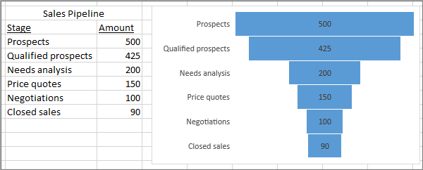

## Create a funnel chart

Funnel charts show values across multiple stages in a process. For example, you could use a funnel chart to show the number of sales prospects at each stage in a sales pipeline. Typically, the values decrease gradually, allowing the bars to resemble a funnel.



### Insert a funnel chart in Excel 2016

1. Set up your data like the above example. Use one column for the stages in the process, and one for the values.
2. Select the data.
3. Click **Insert** > **Insert Waterfall or Stock chart** > **Funnel**.

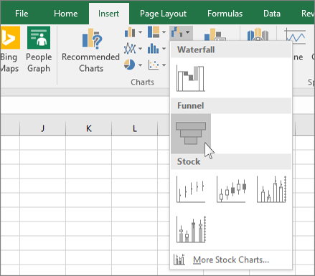

**TIP:** In Excel 2016, use the **Design** and **Format** tabs to customize the look of your chart. If you don't see these tabs, click anywhere in the funnel chart, and then the **Chart Tools** will appear at the top of the program:  
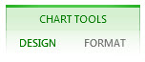

### Insert a funnel chart in Excel Mobile and Excel for Android

1. Set up your data like the above example. Use one column for the stages in the process, and one for the values.
2. Select the data.
3. Click **Insert** > **Chart** > **Funnel**.

### Insert a funnel chart in Outlook, PowerPoint, and Word 2016

1. Click an empty space in an email message, presentation, or document.
2. Click **Insert** > **Chart**> **Funnel**.
3. The funnel chart will appear. And, a small window with example data will appear. Change the numbers to your own.

**TIP:** At the top of the data window is the **Edit Data in Microsoft Excel** button dit data in Microsoft Excel button. Click this button if you want more room to work with the data.

1. To add the names of the stages, right-click anywhere in column A, and then click **Insert**.
2. Click **Entire column**, and then click **OK**.
3. Type the names of the stages in cells A2, A3, and so on.
4. At the top of the program window, click the **Design**tab.
5. Click **Select Data**.

**NOTE:** In PowerPoint, you may have to move the small data window down to see the **Select Data** button.

The **Select Data Source** window will appear. And, dashed lines will appear around the second column of data.

1. In the data, click and drag to select both columns: the stages and the values. When you're done, the dashed lines should surround the two columns.
2. In the **Select Data Source** window, click **OK** to close it.
3. Now close the data window. Or, if you opened Excel to edit your data, close the Excel window.

## Improved autocomplete

Excel autocomplete isn't as picky as it was before. For example, let's say you want to use the NETWORKDAYS function, but you can't remember how it is spelled. If you just type **=DAYS**, the autocomplete menu will bring back all of the functions that contain "DAYS," including, **NETWORKDAYS**. (Before, you had to spell the function name exactly.)

## Functions

### TEXTJOIN

This function combines text from multiple ranges, and each item is separated by a delimiter that you specify. [Learn more about TEXTJOIN here](https://support.office.com/en-us/article/Learn-more-about-TEXTJOIN-here-357b449a-ec91-49d0-80c3-0e8fc845691c).

### CONCAT

This new function is like CONCATENATE, but better. First of all: it's shorter and easier to type. But it also supports range references in addition to cell references. [Learn more here](https://support.office.com/en-us/article/Learn-more-here-9b1a9a3f-94ff-41af-9736-694cbd6b4ca2).

### IFS

Tired of typing complicated, nested IF functions? The IFS function is the solution. With this function, conditions are tested in the order that you specify. If passed, the result is returned. You can also specify an else "catch all" if none of the conditions are met. [Learn about IFS here](https://support.office.com/en-us/article/Learn-about-IFS-here-36329a26-37b2-467c-972b-4a39bd951d45).

### SWITCH

This function evaluates an expression against a list of values in order, and returns the first matching result. If no results match, the "else" is returned. [Details and examples are spelled out here](https://support.office.com/en-us/article/Details-and-examples-are-spelled-out-here-47ab33c0-28ce-4530-8a45-d532ec4aa25e).

### MAXIFS

This function returns the largest number in a range, that meets a single or multiple criteria. [More information available here](https://support.office.com/en-us/article/More-information-available-here-dfd611e6-da2c-488a-919b-9b6376b28883).

### MINIFS

This function is similar to MAXIFS, but it returns the smallest number in a range, that meets a single or multiple criteria. [Read more about the MINIFS function](https://support.office.com/en-us/article/Read-more-about-the-MINIFS-function-6ca1ddaa-079b-4e74-80cc-72eef32e6599).

### FORECAST

The following time series forecasting functions can be used to predict future values based on historical data. These functions use advanced machine learning algorithms, such as Exponential Triple Smoothing (ETS).

* [FORECAST.ETS function](https://support.office.com/en-us/article/FORECASTETS-function-15389b8b-677e-4fbd-bd95-21d464333f41)
* [FORECAST.ETS.SEASONALITY function](https://support.office.com/en-us/article/FORECASTETSSEASONALITY-function-32a27a3b-d22f-42ce-8c5d-ef3649269f3c)
* [FORECAST.LINEAR function](https://support.office.com/en-us/article/FORECASTLINEAR-function-38e2a419-7415-4037-8761-93f3992ace87)
* [FORECAST.ETS.CONFINT function](https://support.office.com/en-us/article/FORECASTETSCONFINT-function-6d4a7557-11fa-4678-9e6a-dbcc31a7c7df)
* [FORECAST.ETS.STAT function](https://support.office.com/en-us/article/FORECASTETSSTAT-function-60f2ae14-d0cf-465e-9736-625ccaaa60b4)

## Charts

### Six new chart types

Visualizations are critical to effective data analysis as well as compelling storytelling. In Excel 2016, we've added six new charts—with the same rich formatting options that you are familiar with—to help you create some of the most commonly used data visualizations of financial or hierarchal information or for revealing statistical properties in your data.

Click **Insert Hierarchy Chart** on the**Insert** tab to use the **Treemap** or **Sunburst** chart, click **Insert Waterfall or Stock Chart** for **Waterfall**, or click **Insert Statistical Chart** for **Histogram**, **Pareto**, or **Box and Whisker**.

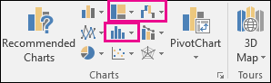

Or click **Recommended Charts** > **All Charts** to see all the new charts.

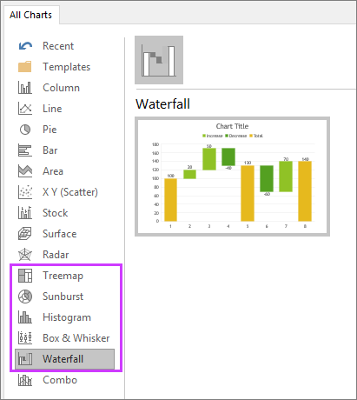

### 3D Maps

Our popular 3D geospatial visualization tool, Power Map, has been renamed and is now available to all Excel 2016 customers and is built into Excel. This innovative set of storytelling capabilities has been renamed 3D Maps and can be found along with other visualization tools by clicking **3D Map** on the **Insert** tab.

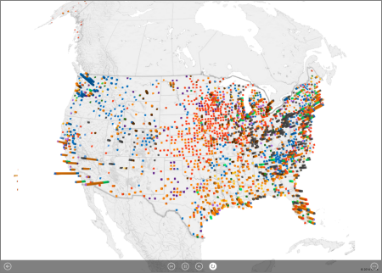

## Available chart types in Office 2016 for Windows

When you create a chart in an Excel worksheet, a Word document, or a PowerPoint presentation, you have a lot of options. Whether you’ll use a chart that’s recommended for your data or one that you’ll pick from the list of all charts, it might help to know a little more about each type of chart.

[Need to get started with creating a chart?](https://support.office.com/en-us/article/Need-to-get-started-with-creating-a-chart-cd131b77-79c7-4537-a438-8db20cea84c0)

If you have already have a chart, but you just want to change its type:

1. Select the chart, click the **Design** tab, and click **Change Chart Type**.

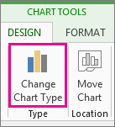

1. Choose a new chart type in the **Change Chart Type** box.

Click a chart type to learn more about it

[Get started with creating a chart](https://support.office.com/en-us/article/Available-chart-types-in-Office-2016-for-Windows-009130aa-04ce-498f-a934-b8917f2365b3" \l "BKMK_GetStarted" \o "Get started with creating a chart)

[Column charts](https://support.office.com/en-us/article/Available-chart-types-in-Office-2016-for-Windows-009130aa-04ce-498f-a934-b8917f2365b3#BKMK_ColumnChart)

[Line charts](https://support.office.com/en-us/article/Available-chart-types-in-Office-2016-for-Windows-009130aa-04ce-498f-a934-b8917f2365b3#BKMK_Line)

[Pie and doughnut charts](https://support.office.com/en-us/article/Available-chart-types-in-Office-2016-for-Windows-009130aa-04ce-498f-a934-b8917f2365b3#BKMK_Pie)

[Bar charts](https://support.office.com/en-us/article/Available-chart-types-in-Office-2016-for-Windows-009130aa-04ce-498f-a934-b8917f2365b3#BKMK_Bar)

[Area charts](https://support.office.com/en-us/article/Available-chart-types-in-Office-2016-for-Windows-009130aa-04ce-498f-a934-b8917f2365b3#BKMK_Area)

[XY (scatter) and bubble charts](https://support.office.com/en-us/article/Available-chart-types-in-Office-2016-for-Windows-009130aa-04ce-498f-a934-b8917f2365b3#BKMK_XY)

[Stock charts](https://support.office.com/en-us/article/Available-chart-types-in-Office-2016-for-Windows-009130aa-04ce-498f-a934-b8917f2365b3#BKMK_Stock)

[Surface charts](https://support.office.com/en-us/article/Available-chart-types-in-Office-2016-for-Windows-009130aa-04ce-498f-a934-b8917f2365b3#BKMK_Surface)

[Radar charts](https://support.office.com/en-us/article/Available-chart-types-in-Office-2016-for-Windows-009130aa-04ce-498f-a934-b8917f2365b3#BKMK_Radar)

[Treemap chart](https://support.office.com/en-us/article/Available-chart-types-in-Office-2016-for-Windows-009130aa-04ce-498f-a934-b8917f2365b3#BKMK_Treemap)

[Sunburst chart](https://support.office.com/en-us/article/Available-chart-types-in-Office-2016-for-Windows-009130aa-04ce-498f-a934-b8917f2365b3#BKMK_Sunburst)

[Histogram charts](https://support.office.com/en-us/article/Available-chart-types-in-Office-2016-for-Windows-009130aa-04ce-498f-a934-b8917f2365b3#BKMK_Histogram)

[Box and Whisker charts](https://support.office.com/en-us/article/Available-chart-types-in-Office-2016-for-Windows-009130aa-04ce-498f-a934-b8917f2365b3#BKMK_BoxWhisker)

[Waterfall charts](https://support.office.com/en-us/article/Available-chart-types-in-Office-2016-for-Windows-009130aa-04ce-498f-a934-b8917f2365b3#BKMK_Waterfall)

[Funnel charts](https://support.office.com/en-us/article/Available-chart-types-in-Office-2016-for-Windows-009130aa-04ce-498f-a934-b8917f2365b3#BKMK_Funnel)

[Combo charts](https://support.office.com/en-us/article/Available-chart-types-in-Office-2016-for-Windows-009130aa-04ce-498f-a934-b8917f2365b3#BKMK_Combo)

Get started with creating a chart

* [Create a chart in Excel](https://support.office.com/en-us/article/Create-a-chart-in-Excel-cd131b77-79c7-4537-a438-8db20cea84c0)
* [Create a chart in Word](https://support.office.com/en-us/article/Create-a-chart-in-Word-ff48e3eb-5e04-4368-a39e-20df7c798932)
* [Create a chart in PowerPoint](https://support.office.com/en-us/article/Create-a-chart-in-PowerPoint-97b2ff96-ca9a-4922-90f9-ea3309ef8e1a)

### Column charts

Data that’s arranged in columns or rows on a worksheet can be plotted in a column chart. A column chart typically displays categories along the horizontal (category) axis and values along the vertical (value) axis, as shown in this chart:

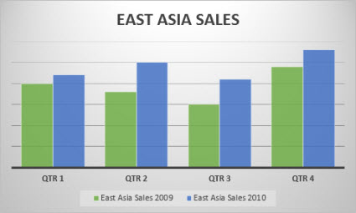

### Types of column charts

* **Clustered column and 3-D clustered column**

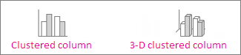

A clustered column chart shows values in 2-D columns. A 3-D clustered column chart shows columns in 3-D format, but it doesn’t use a third value axis (depth axis). Use this chart when you have categories that represent:

* + Ranges of values (for example, item counts).
  + Specific scale arrangements (for example, a Likert scale with entries like Strongly agree, Agree, Neutral, Disagree, Strongly disagree).
  + Names that are not in any specific order (for example, item names, geographic names, or the names of people).
* **Stacked column and 3-D stacked column**     A stacked column chart shows values in 2-D stacked columns. A 3-D stacked column chart shows the stacked columns in 3-D format, but it doesn’t use a depth axis. Use this chart when you have multiple data series and you want to emphasize the total.

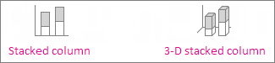

* **100% stacked column and 3-D 100% stacked column**    A 100% stacked column chart shows values in 2-D columns that are stacked to represent 100%. A 3-D 100% stacked column chart shows the columns in 3-D format, but it doesn’t use a depth axis. Use this chart when you have two or more data series and you want to emphasize the contributions to the whole, especially if the total is the same for each category.

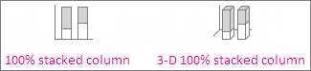

* **3-D column**    3-D column charts use three axes that you can change (a horizontal axis, a vertical axis, and a depth axis), and they compare data points along the horizontal and the depth axes. Use this chart when you want to compare data across both categories and data series.



### Line charts

Data that's arranged in columns or rows on a worksheet can be plotted in a line chart. In a line chart, category data is distributed evenly along the horizontal axis, and all value data is distributed evenly along the vertical axis. Line charts can show continuous data over time on an evenly scaled axis, so they're ideal for showing trends in data at equal intervals, like months, quarters, or fiscal years.

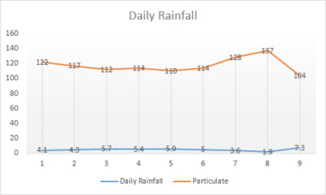

### Types of line charts

* **Line and line with markers**    Shown with or without markers to indicate individual data values, line charts can show trends over time or evenly spaced categories, especially when you have many data points and the order in which they are presented is important. If there are many categories or the values are approximate, use a line chart without markers.

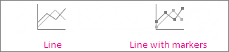

* **Stacked line and stacked line with markers**    Shown with or without markers to indicate individual data values, stacked line charts can show the trend of the contribution of each value over time or evenly spaced categories.

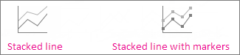

* **100% stacked line and 100% stacked line with markers**    Shown with or without markers to indicate individual data values, 100% stacked line charts can show the trend of the percentage each value contributes over time or evenly spaced categories. If there are many categories or the values are approximate, use a 100% stacked line chart without markers.



* **3-D line**    3-D line charts show each row or column of data as a 3-D ribbon. A 3-D line chart has horizontal, vertical, and depth axes that you can change.



**NOTES:**

* + Line charts work best when you have multiple data series in your chart—if you have only one data series, consider using a [scatter chart](https://support.office.com/en-us/article/Available-chart-types-in-Office-2016-for-Windows-009130aa-04ce-498f-a934-b8917f2365b3#BKMK_XY) instead.
  + Stacked line charts sum the data, which might not be the result you want. It might not be easy to see that the lines are stacked, so consider using a different line chart type or a [stacked area chart](https://support.office.com/en-us/article/Available-chart-types-in-Office-2016-for-Windows-009130aa-04ce-498f-a934-b8917f2365b3#BKMK_Area) instead.

### Pie and doughnut charts

Data that's arranged in one column or row on a worksheet can be plotted in a pie chart. Pie charts show the size of items in one data series, proportional to the sum of the items. The data points in a pie chart are shown as a percentage of the whole pie.

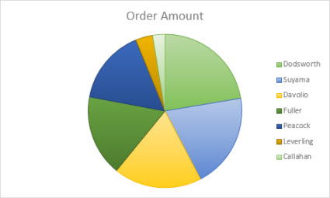

Consider using a pie chart when:

* You have only one data series.
* None of the values in your data are negative.
* Almost none of the values in your data are zero values.
* You have no more than seven categories, all of which represent parts of the whole pie.

Types of pie charts

* **Pie and 3-D pie**    Pie charts show the contribution of each value to a total in a 2-D or 3-D format. You can pull out slices of a pie chart manually to emphasize the slices.

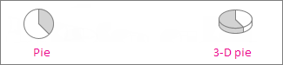

* **Pie of pie and bar of pie**    Pie of pie or bar of pie charts show pie charts with smaller values pulled out into a secondary pie or stacked bar chart, which makes them easier to distinguish.

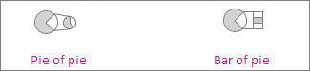

### Doughnut charts

Data that's arranged in columns or rows only on a worksheet can be plotted in a doughnut chart. Like a pie chart, a doughnut chart shows the relationship of parts to a whole, but it can contain more than one data series.

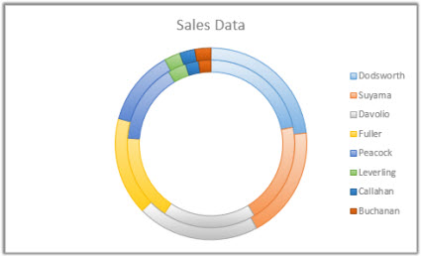

### Types of doughnut charts

* **Doughnut**    Doughnut charts show data in rings, where each ring represents a data series. If percentages are shown in data labels, each ring will total 100%.



**NOTE:**  Doughnut charts aren't easy to read. You may want to use a [stacked column charts](https://support.office.com/en-us/article/Available-chart-types-in-Office-2016-for-Windows-009130aa-04ce-498f-a934-b8917f2365b3#BKMK_ColumnChart) or [Stacked bar chart](https://support.office.com/en-us/article/Available-chart-types-in-Office-2016-for-Windows-009130aa-04ce-498f-a934-b8917f2365b3#BKMK_Bar) instead.

### Bar charts

Data that's arranged in columns or rows on a worksheet can be plotted in a bar chart. Bar charts illustrate comparisons among individual items. In a bar chart, the categories are typically organized along the vertical axis, and the values along the horizontal axis.

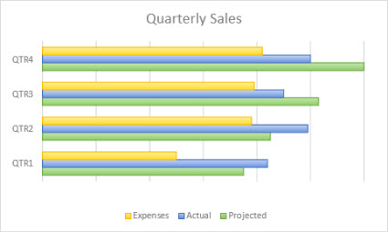

Consider using a bar chart when:

* The axis labels are long.
* The values that are shown are durations.

### Types of bar charts

* **Clustered bar and 3-D clustered bar**    A clustered bar chart shows bars in 2-D format. A 3-D clustered bar chart shows bars in 3-D format; it doesn’t use a depth axis.

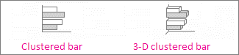

* **Stacked bar and 3-D stacked bar**    Stacked bar charts show the relationship of individual items to the whole in 2-D bars. A 3-D stacked bar chart shows bars in 3-D format; it doesn’t use a depth axis.

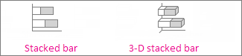

* **100% stacked bar and 3-D 100% stacked bar**    A 100% stacked bar shows 2-D bars that compare the percentage that each value contributes to a total across categories. A 3-D 100% stacked bar chart shows bars in 3-D format; it doesn’t use a depth axis.

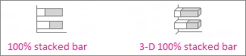

### Area charts

Data that's arranged in columns or rows on a worksheet can be plotted in an area chart. Area charts can be used to plot change over time and draw attention to the total value across a trend. By showing the sum of the plotted values, an area chart also shows the relationship of parts to a whole.

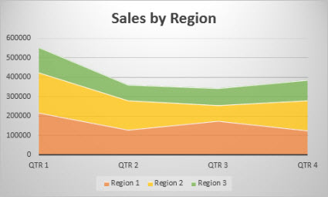

### Types of area charts

* **Area and 3-D area**    Shown in 2-D or in 3-D format, area charts show the trend of values over time or other category data. 3-D area charts use three axes (horizontal, vertical, and depth) that you can change. As a rule, consider using a [line chart](https://support.office.com/en-us/article/line-chart-a019c053-ba7f-4c46-a09a-82e17f3ee5be#__line_charts) instead of a non-stacked area chart, because data from one series can be hidden behind data from another series.

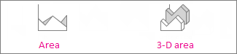

* **Stacked area and 3-D stacked area**    Stacked area charts show the trend of the contribution of each value over time or other category data in 2-D format. A 3-D stacked area chart does the same, but it shows areas in 3-D format without using a depth axis.

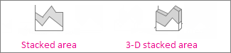

* **100% stacked area and 3-D 100% stacked area**    100% stacked area charts show the trend of the percentage that each value contributes over time or other category data. A 3-D 100% stacked area chart does the same, but it shows areas in 3-D format without using a depth axis.

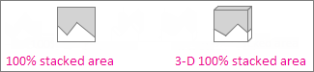

### XY (scatter) and bubble charts

Data that's arranged in columns and rows on a worksheet can be plotted in an xy (scatter) chart. Place the x values in one row or column, and then enter the corresponding y values in the adjacent rows or columns.

A scatter chart has two value axes: a horizontal (x) and a vertical (y) value axis. It combines x and y values into single data points and shows them in irregular intervals, or clusters. Scatter charts are typically used for showing and comparing numeric values, like scientific, statistical, and engineering data.

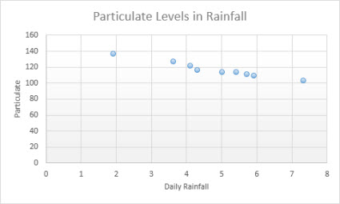

Consider using a scatter chart when:

* You want to change the scale of the horizontal axis.
* You want to make that axis a logarithmic scale.
* Values for horizontal axis are not evenly spaced.
* There are many data points on the horizontal axis.
* You want to adjust the independent axis scales of a scatter chart to reveal more information about data that includes pairs or grouped sets of values.
* You want to show similarities between large sets of data instead of differences between data points.
* You want to compare many data points without regard to time—the more data that you include in a scatter chart, the better the comparisons you can make.

### Types of scatter charts

* **Scatter**    This chart shows data points without connecting lines to compare pairs of values.



* **Scatter with smooth lines and markers and scatter with smooth lines**    This chart shows a smooth curve that connects the data points. Smooth lines can be shown with or without markers. Use a smooth line without markers if there are many data points.



* **Scatter with straight lines and markers and scatter with straight lines**    This chart shows straight connecting lines between data points. Straight lines can be shown with or without markers.

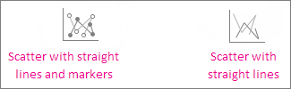

### Bubble charts

Much like a scatter chart, a bubble chart adds a third column to specify the size of the bubbles it shows to represent the data points in the data series.

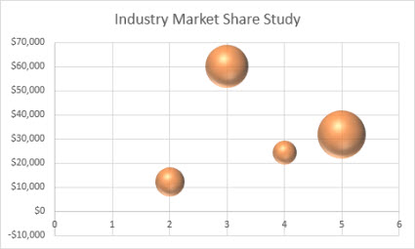

### Type of bubble charts

* **Bubble or bubble with 3-D effect**    Both of these bubble charts compare sets of three values instead of two, showing bubbles in 2-D or 3-D format (without using a depth axis). The third value specifies the size of the bubble marker.

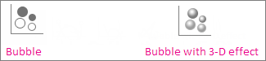

### Stock charts

Data that's arranged in columns or rows in a specific order on a worksheet can be plotted in a stock chart. As the name implies, stock charts can show fluctuations in stock prices. However, this chart can also show fluctuations in other data, like daily rainfall or annual temperatures. Make sure you organize your data in the right order to create a stock chart.

For example, to create a simple high-low-close stock chart, arrange your data with High, Low, and Close entered as column headings, in that order.

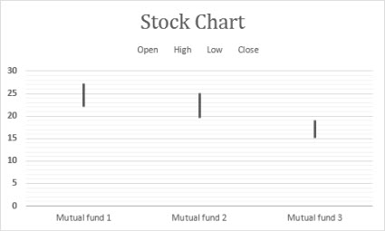

### Types of stock charts

* **High-low-close**    This stock chart uses three series of values in the following order: high, low, and then close.



* **Open-high-low-close**    This stock chart uses four series of values in the following order: open, high, low, and then close.



* **Volume-high-low-close**    This stock chart uses four series of values in the following order: volume, high, low, and then close. It measures volume by using two value axes: one for the columns that measure volume, and the other for the stock prices.



* **Volume-open-high-low-close**    This stock chart uses five series of values in the following order: volume, open, high, low, and then close.



### Surface charts

Data that's arranged in columns or rows on a worksheet can be plotted in a surface chart. This chart is useful when you want to find optimum combinations between two sets of data. As in a topographic map, colors and patterns indicate areas that are in the same range of values. You can create a surface chart when both categories and data series are numeric values.

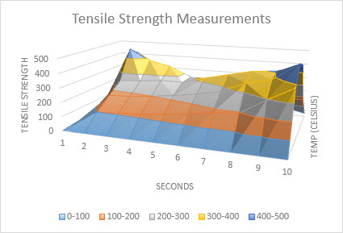

### Types of surface charts

* **3-D surface**    This chart shows a 3-D view of the data, which can be imagined as a rubber sheet stretched over a 3-D column chart. It is typically used to show relationships between large amounts of data that may otherwise be difficult to see. Color bands in a surface chart do not represent the data series; they indicate the difference between the values.



* **Wireframe 3-D surface**    Shown without color on the surface, a 3-D surface chart is called a wireframe 3-D surface chart. This chart shows only the lines. A wireframe 3-D surface chart isn’t easy to read, but it can plot large data sets much faster than a 3-D surface chart.



* **Contour**    Contour charts are surface charts viewed from above, similar to 2-D topographic maps. In a contour chart, color bands represent specific ranges of values. The lines in a contour chart connect interpolated points of equal value.



* **Wireframe contour**    Wireframe contour charts are also surface charts viewed from above. Without color bands on the surface, a wireframe chart shows only the lines. Wireframe contour charts aren’t easy to read. You may want to use a 3-D surface chart instead.



### Radar charts

Data that's arranged in columns or rows on a worksheet can be plotted in a radar chart. Radar charts compare the aggregate values of several data series.

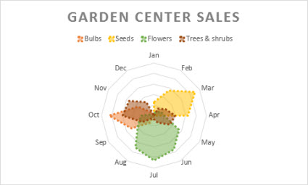

### Type of radar charts

* **Radar and radar with markers**    With or without markers for individual data points, radar charts show changes in values relative to a center point.

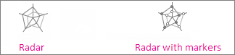

* **Filled radar**    In a filled radar chart, the area covered by a data series is filled with a color.



### Treemap chart

The treemap chart provides a hierarchical view of your data and an easy way to compare different levels of categorization. The treemap chart displays categories by color and proximity and can easily show lots of data which would be difficult with other chart types. The treemap chart can be plotted when empty (blank) cells exist within the hierarchal structure and treemap charts are good for comparing proportions within the hierarchy.

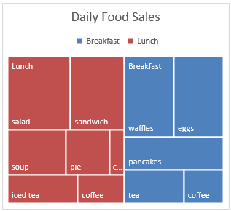

There are no chart sub-types for treemap charts.

### Sunburst chart

The sunburst chart is ideal for displaying hierarchical data and can be plotted when empty (blank) cells exist within the hierarchal structure . Each level of the hierarchy is represented by one ring or circle with the innermost circle as the top of the hierarchy. A sunburst chart without any hierarchical data (one level of categories), looks similar to a doughnut chart. However, a sunburst chart with multiple levels of categories shows how the outer rings relate to the inner rings. The sunburst chart is most effective at showing how one ring is broken into its contributing pieces.

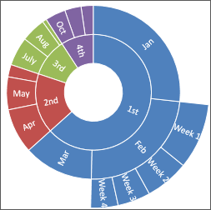

There are no chart sub-types for sunburst charts.

### Histogram charts

Data plotted in a histogram chart shows the frequencies within a distribution. Each column of the chart is called a bin, which can be changed to further analyze your data.

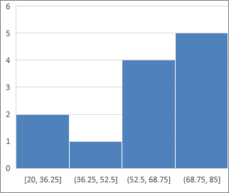

### Type of histogram charts

* **Histogram**    The histogram chart shows the distribution of your data grouped into frequency bins.

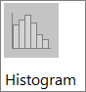

* **Pareto chart**    A pareto is a sorted histogram chart that contains both columns sorted in descending order and a line representing the cumulative total percentage.

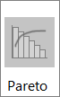

### Box and Whisker charts

A box and whisker chart shows distribution of data into quartiles, highlighting the mean and outliers. The boxes may have lines extending vertically called “whiskers”. These lines indicate variability outside the upper and lower quartiles, and any point outside those lines or whiskers is considered an outlier. Use this chart type when there are multiple data sets which relate to each other in some way.

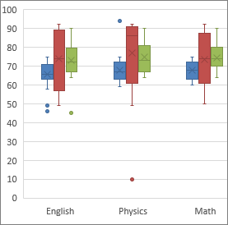

There are no chart sub-types for box and whisker charts.

### Waterfall charts

A waterfall chart shows a running total of your financial data as values are added or subtracted. It's useful for understanding how an initial value is affected by a series of positive and negative values. The columns are color coded so you can quickly tell positive from negative numbers.

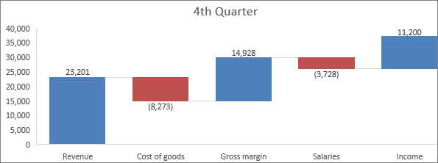

There are no chart sub-types for waterfall charts.

### Funnel charts

Funnel charts show values across multiple stages in a process.



Typically, the values decrease gradually, allowing the bars to resemble a funnel. [Read more about funnel charts here](https://support.office.com/en-us/article/Read-more-about-funnel-charts-here-ba21bcba-f325-4d9f-93df-97074589a70e).

### Combo charts

Data that's arranged in columns and rows can be plotted in a combo chart. Combo charts combine two or more chart types to make the data easy to understand, especially when the data is widely varied. Shown with a secondary axis, this chart is even easier to read. In this example, we used a column chart to show the number of homes sold between January and June and then used a line chart to make it easier for readers to quickly identify the average sales price by month.

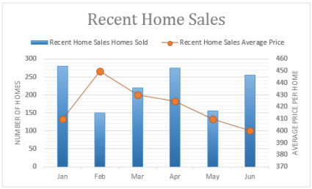

### Type of combo charts

* **Clustered column – line and clustered column – line on secondary axis**    With or without a secondary axis, this chart combines a clustered column and line chart, showing some data series as columns and others as lines in the same chart.

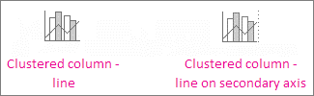

* **Stacked area – clustered column**    This chart combines a stacked area and clustered column chart, showing some data series as stacked areas and others as columns in the same chart.



* **Custom combination**    This chart lets you combine the charts you want to show in the same chart.



### See Also

[Create a funnel chart](https://support.office.com/en-us/article/Create-a-funnel-chart-ba21bcba-f325-4d9f-93df-97074589a70e)

[Create a histogram](https://support.office.com/en-us/article/Create-a-histogram-85680173-064b-4024-b39d-80f17ff2f4e8)

[Create a Pareto chart](https://support.office.com/en-us/article/Create-a-Pareto-chart-a1512496-6dba-4743-9ab1-df5012972856)

[Create a sunburst chart in Office 2016](https://support.office.com/en-us/article/Create-a-sunburst-chart-in-Office-2016-4a127977-62cd-4c11-b8c7-65b84a358e0c)

[Create a treemap chart in Office 2016](https://support.office.com/en-us/article/Create-a-treemap-chart-in-Office-2016-dfe86d28-a610-4ef5-9b30-362d5c624b68)

[Create a waterfall chart in Office 2016](https://support.office.com/en-us/article/Create-a-waterfall-chart-in-Office-2016-8de1ece4-ff21-4d37-acd7-546f5527f185)

[Create a box and whisker chart](https://support.office.com/en-us/article/Create-a-box-and-whisker-chart-62f4219f-db4b-4754-aca8-4743f6190f0d)

[Add a pie chart](https://support.office.com/en-us/article/Add-a-pie-chart-812dccce-9e44-41c6-9091-225c7c3df3e0)

[Create a chart in Excel 2016 for Windows](https://support.office.com/en-us/article/Create-a-chart-in-Excel-2016-for-Windows-cd131b77-79c7-4537-a438-8db20cea84c0)

## Get and transform (Query)

Before analysis can begin, you must be able to bring in the data relevant to the business question you are trying to answer. Excel 2016 now comes with built-in functionality that brings ease and speed to getting and transforming your data—allowing you to find and bring all the data you need into one place. These new capabilities, previously only available as a separate add-in called Power Query, can be found natively within Excel. Access them from the **Get & Transform** group on the **Data** tab.

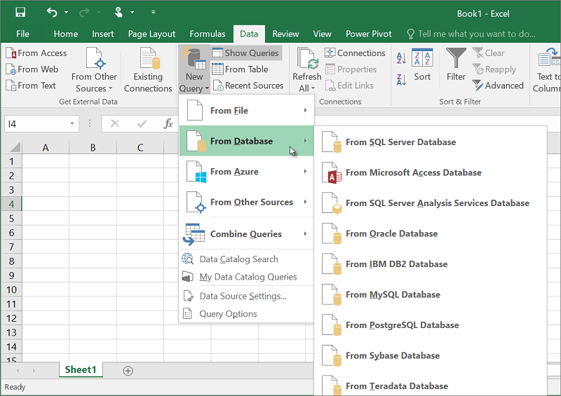

### One click forecasting

In previous versions of Excel, only linear forecasting had been available. In Excel 2016, the FORECAST function has been extended to allow forecasting based on Exponential Smoothing (such as, FORECAST.ETS() …). This functionality is also available as a new one-click forecasting button. On the **Data** tab, click the **Forecast Sheet** button to quickly create a forecast visualization of your data series. From the wizard, you can also find options to adjust common forecast parameters, like seasonality, which is automatically detected by default and confidence intervals.

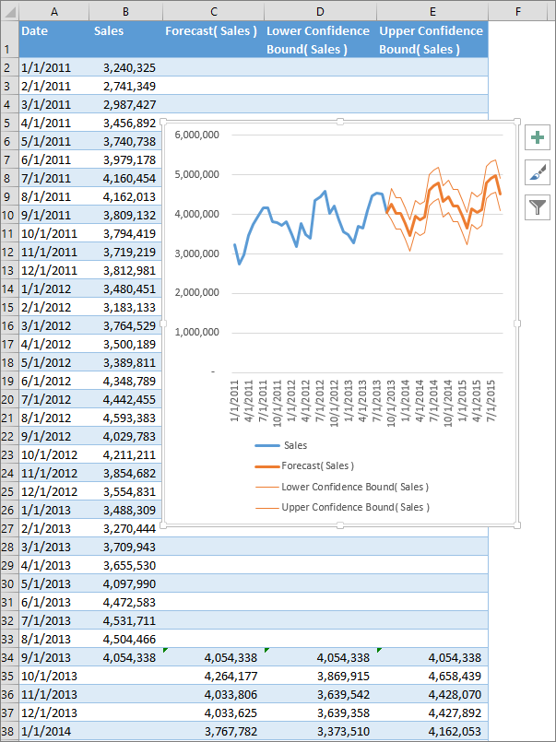

### Getting Started with Get & Transform in Excel 2016

With **Get & Transform** in Excel 2016, you can search for data sources, make connections, and then *shape* that data (for example remove a column, change a data type, or merge tables) in ways that meet your needs. Once you’ve shaped your data, you can share your findings or use your query to create reports.

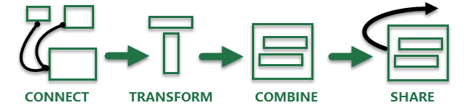

Looking at those steps in order, they often occur like this:

* **Connect** – make connections to data sitting in the cloud, in a service, or locally
* **Transform** – shape the data to meet your needs; the original source remains unchanged
* **Combine** – create a data model from multiple data sources, and get a unique view into the data
* **Share** – once your query is complete you can save it, share it, or use it for reports

Whenever you connect to data, transform it, or combine it with other data sources, a feature of **Get & Transform**called **Query Editor** records each step, and lets you modify each step in any way you need. **Query Editor** also lets you undo, redo, change the order, or modify any step… all so you can shape your view of the connected data just the way you want it.

With **Get & Transform**, you can create queries that are as simple or complex as you need. As you add steps to a query, **Query Editor** works behind the scenes to create a set of discrete instructions that carry out your commands. Those instructions are created in the M Language. Users who enjoy the power and flexibility of data scripting can create M Language to manually create (or tweak ) queries using the **Advanced Editor**. All of this power and flexibility, whether creating steps automatically or manually, is part of the **Get & Transform** collection of features in Excel 2016. **Query Editor** and the **Advanced Editor** are described in more detail later in this article.

You can begin a new query by selecting the **New Query** button from the **Get & Transform** ribbon in Excel 2016.

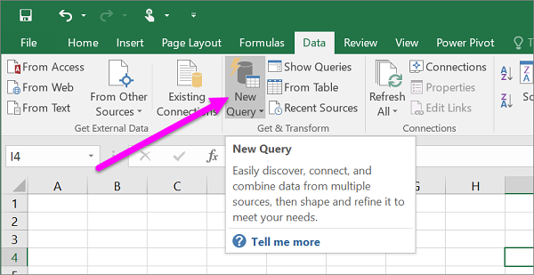

**NOTE:** This technology is also available for previous versions of Excel with the **Power Query Add-In**, which is available as a [download](https://support.office.com/en-us/article/Whats-new-in-Power-Query-936b2fca-4168-41ad-bbbd-7b83856b6776), as well as in **Power BI**. To see **Power Query** in action in previous versions of Excel, take a look at [Getting Started with Power Query](https://support.office.com/en-us/article/Getting-Started-with-Power-Query-7104fbee-9e62-4cb9-a02e-5bfb1a6c536a).

### Connect

You can use a query to connect to a single data source, such as an **Access** database, or you can connect to multiple files, databases, OData feeds, or Web sites scattered across the Internet. With **Get & Transform**, you can then bring all those sources together using your own unique combinations, and uncover insights you otherwise wouldn’t have seen.

When you select **New Query** from the **Get & Transform** ribbon section in the **Data** tab, the available data sources are presented in a menu. There are many data sources to choose from, including files like Excel **workbooks** or CSV files, databases such as **Access**, **SQL Server**, **Oracle**, and **MySQL**, **Azure** services such as **HDInsight** or**Blob Storage**, and all sorts of other sources such as the **Web**, **SharePoint Lists**, **Hadoop Files**, **Facebook**,**Salesforce**, and many others.

**NOTE:** Some data sources are only available on Professional and Professional Plus licenses.



When you connect to a data source, **Get & Transform** displays a **Navigator**window, which allows you to edit the data from the source. When you select **Edit** from the **Navigator** window, **Get & Transform** launches **Query Editor**, a dedicated window that facilitates and displays your data connections and the transformations you apply. The next section, **Transform**, provides more information about **Query Editor**.

### Transform

**Get & Transform** lets you *transform* the data from your data sources in ways that help you analyze it. *Transforming*data means modifying it in some way to meet your needs – for example, you could remove a column, change a data type, or merge tables – each of which is a data transformation. As you transform data, it collectively takes on the shape you need to further your analysis. The process of applying transformations to one or more sets of data is often called *shaping* data.

Excel uses a dedicated window called **Query Editor** to facilitate and display data transformations. When you select**New Query** from the **Get & Transform** ribbon section of the **Data** tab, then select the data source (such as a workbook, or a database), the **Navigator** window appears so you can select which table (or tables) you want to use in your query. When you select a table, a preview of its data is shown in the right pane of the **Navigator**window.

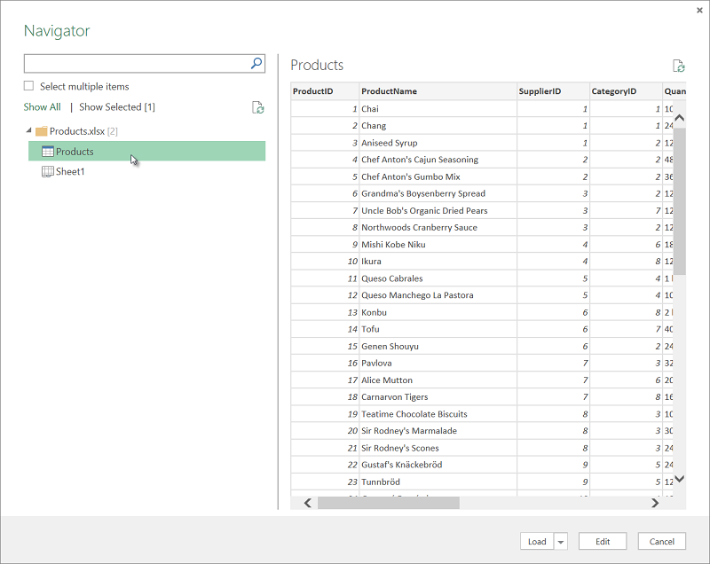

If you select **Load**, the data source is brought into Excel directly. In this case, we select **Edit** to launch **Query Editor**.

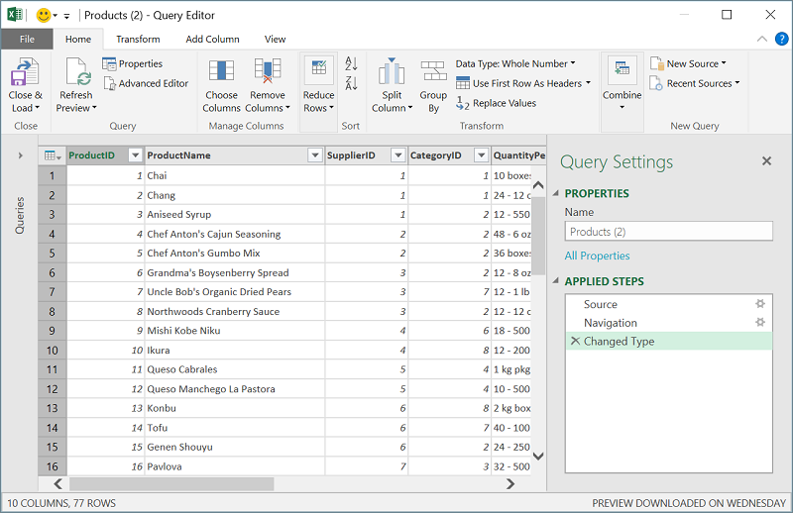

**Query Editor** keeps track of everything you do with the data. **Query Editor** records and labels each transformation, or step, you apply to the data. Whether the transformation is a data connection (a data *source*), a column removal, a merge, or a data type change, **Query Editor** tracks each operation in the **APPLIED STEPS** section of the **Query Settings** pane.

The transformations you apply to your data connections collectively constitute your *query*.

It’s important (and helpful) to realize that the actions you define in **Query Editor** don't change the original source data. Instead, Excel records each step you take when connecting or transforming the data, and once you’ve finished shaping the data, it takes a snapshot of the refined data set and brings it into the workbook.

There are many, many transformations you can apply to data. You can also write your own transformations using the M Language (which is how **Query Editor** records steps in the background), using Query Editor’s **Advanced Editor**. You can open the **Advanced Editor** from Query Editor’s **View** ribbon, where you can modify the M Language steps associated with the existing query. You can also create queries from scratch using the **Advanced Editor**.

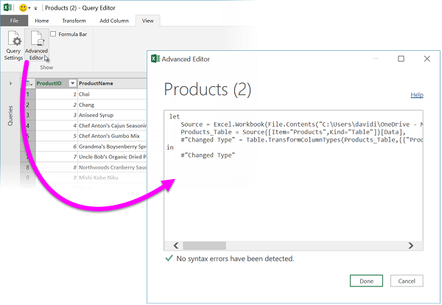

When you’re done creating your query you can select **Close & Load** from the **Home** ribbon tab, and the query results are loaded into Excel and available in a new workbook tab.

Learn more about **Transform**:

* [Introduction to the Query Editor (Power Query)](https://support.office.com/en-us/article/Introduction-to-the-Query-Editor-Power-Query-1d6cdb63-bf70-4ae8-a7d5-6ae9547004d9)
* [Add a query to an Excel worksheet (Power Query)](https://support.office.com/en-us/article/Add-a-query-to-an-Excel-worksheet-Power-Query-ca69e0f0-3db1-4493-900c-6279bef08df4)
* [Edit query step settings (Power Query)](https://support.office.com/en-us/article/Edit-query-step-settings-Power-Query-3e221afc-c764-4cd9-9a96-a5a5a7688e46)
* [Shape data (Power Query)](https://support.office.com/en-us/article/Shape-data-Power-Query-9b2dac2b-e13d-46a4-8940-7bc55f44597d)

### Share

When you save an Excel workbook that contains a query, the query is *automatically saved* as well. You can view all queries in an Excel workbook by selecting **Show Queries** from the **Get & Transform** ribbon section of the **Data**tab.

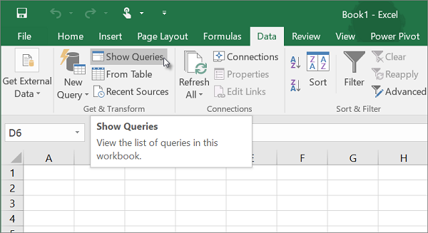

The **Workbook Queries** pane shows all queries in the workbook.

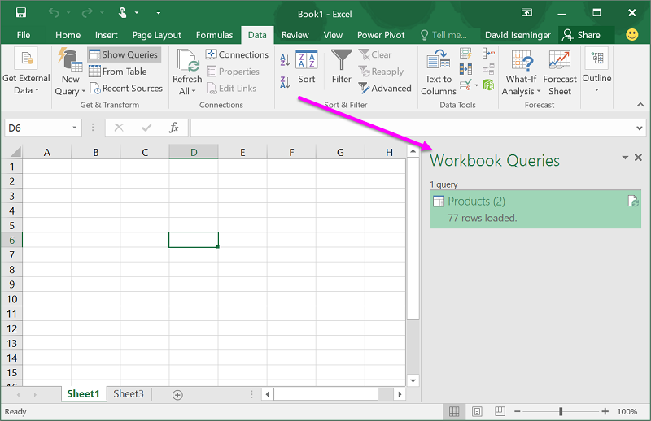

But why stop there? With the **Power BI Data Catalog**, you can share your queries with anyone in your organization. Or create a query that you’ll use frequently, then use it in multiple workbooks and save yourself work. Instead of saving and emailing Excel workbooks (and trying to juggle which version is the original, what has changed, or whether its data is stale!), save a query to the **Data Catalog** and avoid the headache of countless untracked workbook versions filling inboxes. Just right-click on a query in the **Workbook Queries** pane, and a menu provides all sorts of options, including **Send To Data Catalog**.

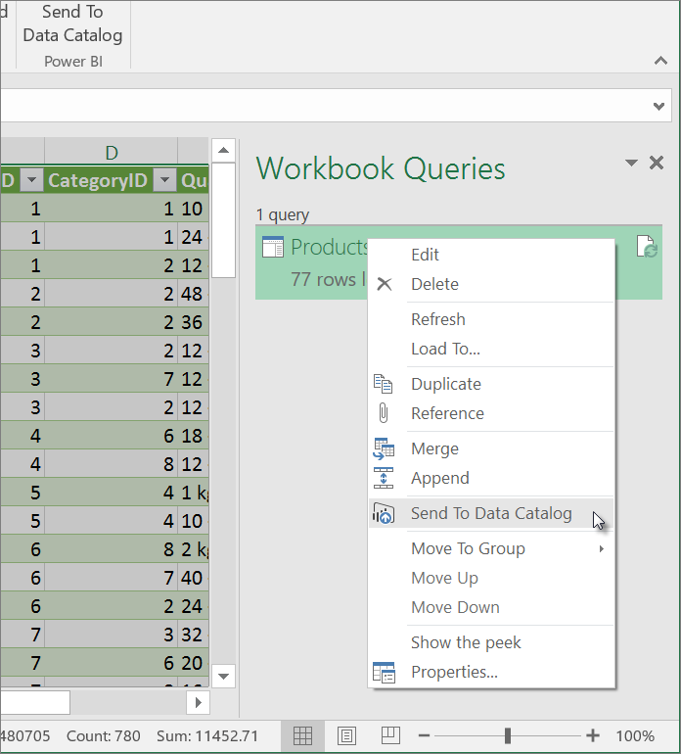

Notice the other options in the right-click menu, too. You can **Duplicate** a query, which lets you change certain elements (or all elements) of a query without changing the original query; it’s like creating a query template that you can then modify to create customized datasets – like one dataset for retail, another for wholesale, and another for inventory, all of them based on the same data connections.

You can also **Merge** or **Append** queries, which lets you turn queries into reusable building blocks.

You can also publish your workbook to Power BI, and create online reports that can be shared with your group, refreshed automatically, and refined. To publish a workbook to Power BI, select **File > Publish > Publish to Power BI**.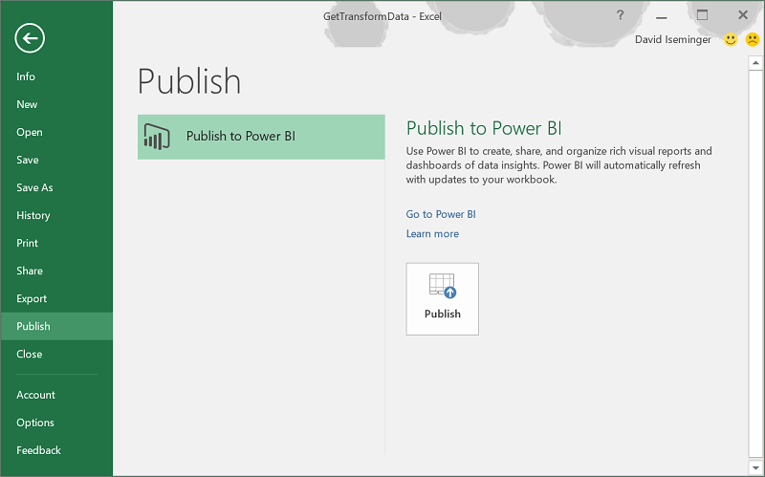

**NOTE:** Your workbook must be saved to **OneDrive for Business** to publish it to Power BI.

With your query complete, you can use it to create reports in **Excel**, or in **Power BI**. Take a look at the following section to learn more about reporting resources that let you take advantage of all the good work you did when using **Get & Transform** functionality to shape data just the way you want it.

### Learn more about Share:

* [Publish to Power BI](https://support.office.com/en-us/article/Publish-to-Power-BI-7342b49c-6567-4155-a7ac-acdc14d9ad0f)
* [View and Manage Queries in a Workbook (Power Query)](https://support.office.com/en-us/article/View-and-Manage-Queries-in-a-Workbook-Power-Query-76f93a6d-37d9-46b5-bc40-d5f2162401f5)
* [Share queries in the Power BI Data Catalog](https://support.office.com/en-us/article/Share-queries-in-the-Power-BI-Data-Catalog-353b6b69-47f8-422e-bf7e-db70bca51eea)
* [Combine multiple queries (Power Query)](https://support.office.com/en-us/article/Combine-multiple-queries-Power-Query-16b1421c-9708-466a-8d6e-30a324949722)
* [Merge queries (Power Query)](https://support.office.com/en-us/article/Merge-queries-Power-Query-fd157620-5470-4c0f-b132-7ca2616d17f9)

## Create a forecast in Excel 2016 for Windows

If you have historical time-based data, you can use it to create a forecast. When you create a forecast, Excel creates a new worksheet that contains both a table of the historical and predicted values and a chart that expresses this data. A forecast can help you predict things like future sales, inventory requirements, or consumer trends.

Information about [how the forecast is calculated](https://support.office.com/en-us/article/Create-a-forecast-in-Excel-2016-for-Windows-22c500da-6da7-45e5-bfdc-60a7062329fd#BKMK_Calculation) and [options you can change](https://support.office.com/en-us/article/Create-a-forecast-in-Excel-2016-for-Windows-22c500da-6da7-45e5-bfdc-60a7062329fd#BKMK_Dialog) can be found at the bottom of this article.



## Create a forecast

1. In a worksheet, enter two data series that correspond to each other:
   * A series with date or time entries for the timeline
   * A series with corresponding values

These values will be predicted for future dates.

1. **NOTE:** The timeline requires consistent intervals between its data points. For example, monthly intervals with values on the 1st of every month, yearly intervals, or numerical intervals. It’s okay if your timeline series is missing up to 30% of the data points, or has several numbers with the same time stamp. The forecast will still be accurate. However, summarizing data before you create the forecast will produce more accurate forecast results.
2. Select both data series.

**TIP:** If you select a cell in one of your series, Excel automatically selects the rest of the data.

1. On the **Data** tab, in the **Forecast** group, click **Forecast Sheet**.

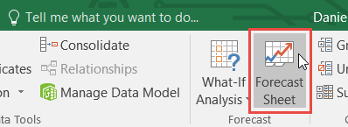

1. In the **Create Forecast Worksheet** box, pick either a line chart or a column chart for the visual representation of the forecast.

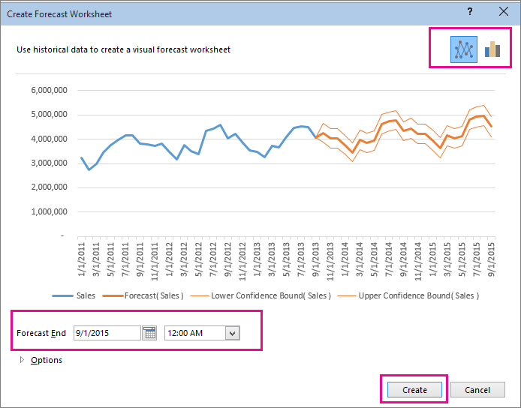

1. In the **Forecast End** box, pick an end date, and then click **Create**.

Excel creates a new worksheet that contains both a table of the historical and predicted values and a chart that expresses this data.

You'll find the new worksheet just to the left ("in front of") the sheet where you entered the data series.

## Customize your forecast

If you want to change any advanced settings for your forecast, click **Options**.

You'll find information about each of the options in the following table.

|  |  |
| --- | --- |
| **Forecast Options** | **Description** |
| **Forecast Start** | Pick the date for the forecast to begin. When you pick a date before the end of the historical data, only data prior to the start date are used in the prediction (this is sometimes referred to as "hindcasting").  **TIPS:**   * Starting your forecast before the last historical point gives you a sense of the prediction accuracy as you can compare the forecasted series to the actual data. However, if you start the forecast too early, the forecast generated won't necessarily represent the forecast you'll get using all the historical data. Using all of your historical data gives you a more accurate prediction. * If your data is seasonal, then starting a forecast before the last historical point is recommended. |
| **Confidence Interval** | Check or uncheck **Confidence Interval** to show or hide it. The confidence interval is the range surrounding each predicted value, in which 95% of future points are expected to fall, based on the forecast (with normal distribution). Confidence interval can help you figure out the accuracy of the prediction. A smaller interval implies more confidence in the prediction for the specific point. The default level of 95% confidence can be changed using the up or down arrows. |
| **Seasonality** | Seasonality is a number for the length (number of points) of the seasonal pattern and is automatically detected. For example, in a yearly sales cycle, with each point representing a month, the seasonality is 12. You can override the automatic detection by choosing **Set Manually**and then picking a number.  **NOTE:** When setting seasonality manually, avoid a value for less than 2 cycles of historical data. With less than 2 cycles, Excel cannot identify the seasonal components. And when the seasonality is not significant enough for the algorithm to detect, the prediction will revert to a linear trend. |
| **Timeline Range** | Change the range used for your timeline here. This range needs to match the **Values Range**. |
| **Values Range** | Change the range used for your value series here. This range needs to be identical to the**Timeline Range**. |
| **Fill Missing Points Using** | To handle missing points, Excel uses interpolation, meaning that a missing point will be completed as the weighted average of its neighboring points as long as fewer than 30% of the points are missing. To treat the missing points as zeros instead, click **Zeros** in the list. |
| **Duplicate Aggregates Using** | When your data contains multiple values with the same timestamp, Excel will average the values. To use another calculation method, such as **Median**, pick the calculation from the list. |
| **Include Forecast Statistics** | Check this box if you want additional statistical information on the forecast included in a new worksheet. Doing this adds a table of statistics generated using the [FORECAST.ETS.STAT](https://support.office.com/en-us/article/FORECASTETSSTAT-897a2fe9-6595-4680-a0b0-93e0308d5f6e#_forecast.ets.stat) function and includes measures, such as the smoothing coefficients (Alpha, Beta, Gamma), and error metrics (MASE, SMAPE, MAE, RMSE). |

Formulas used in forecasting data

When you use a formula to create a forecast, it returns a table with the historical and predicted data, and a chart. The forecast predicts future values using your existing time-based data and the AAA version of the Exponential Smoothing (ETS) algorithm.

The table can contain the following columns, three of which are calculated columns:

* Historical time column (your time-based data series)
* Historical values column (your corresponding values data series)
* Forecasted values column (calculated using [FORECAST.ETS](https://support.office.com/en-us/article/FORECASTETS-897a2fe9-6595-4680-a0b0-93e0308d5f6e#_forecast.ets))
* Two columns representing the confidence interval (calculated using [FORECAST.ETS.CONFINT](https://support.office.com/en-us/article/FORECASTETSCONFINT-897a2fe9-6595-4680-a0b0-93e0308d5f6e#_forecast.ets.confint)). These columns appear only when the **Confidence Interval** is checked in the **Options** section of the box.

## Templates

### Financial templates

Take advantage of the new [My Cashflow template](https://support.office.com/en-us/article/My-Cashflow-template-215e9e2e-5813-41ad-a9ef-a0c0874841bb), and the [Stock Analysis template](https://support.office.com/en-us/article/Stock-Analysis-template-f65e62ac-7af6-4cc6-98f3-f68b147ed65d). These templates track what you earn, how much you spend, and where your spending occurs. Plus, quickly analyze and compare the performance of selected stocks over time.

### Calendar Insights Template

[View your calendar as a dashboard](https://support.office.com/en-us/article/View-your-calendar-as-a-dashboard-7edbeb88-99ca-403f-a394-7e957d3d3f40) and drill into the data. You'll get a better handle on how you spend your time, and identify ways to get more out of your days.

## Learn how to use the My Cashflow template with Excel 2016

With Excel 2016, you can analyze different types of data from all sorts of different sources, and for many different reasons. In this article, you learn how to use the built-in **My Cashflow** template in Excel 2016 to manage the money you earn, how much you spend, and where your spending occurs.

### Using the My Cashflow template

The **My Cashflow** template is a simple example of how Excel 2016 and analyze, model, and present data to you interesting and insightful ways. The template is a great way to become familiar with the data analysis capabilities of Excel 2016, and to demonstrate how the built-in templates in Excel can make data analysis easy.

In this article, you learn how to do the following with Excel 2016:

1. Perform *data modeling*, using the built-in modeling capabilities of Excel.
2. Put some of Excel's *time intelligence* functionality to work.
3. Learn how the My Cashflow template was created, using powerful calculations called *Measures* that you can use in your workbooks as well.

### Open the My Cashflow template

To open the My Cashflow template, select **New > Business analysis feature tour**.

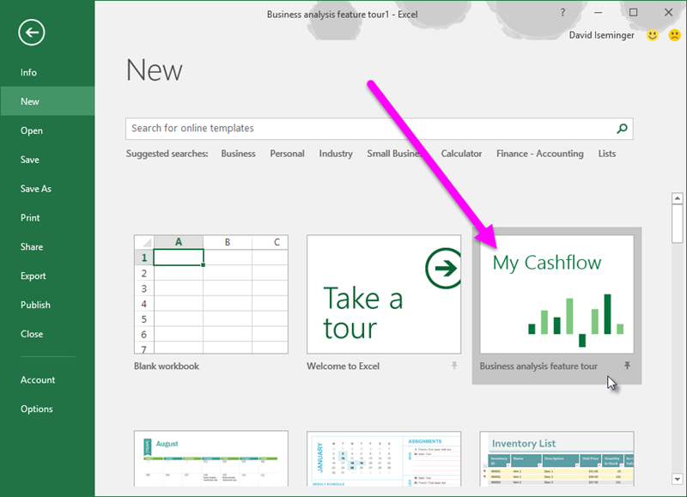

If you can't see the template, use the search box and type *business analysis feature tour*, and then select the magnifying glass button to begin the search (or click the Enter key). The My Cashflow template appears.

Once the template is open, you see the first workbook tab, titled **Start**. Select the **Lets' get started** button to begin.

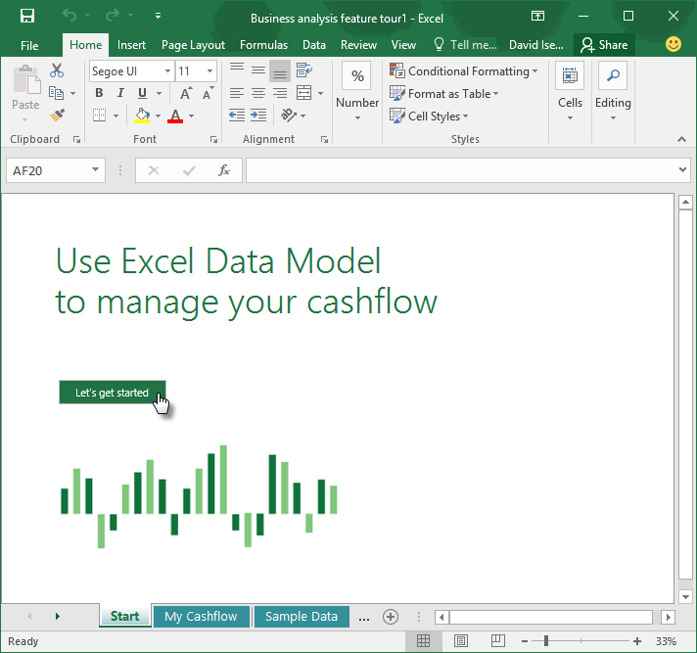

The My Cashflow workbook tab is selected, showing you the cashflow report for the selected year. This cashflow graph displays a year-over-year cashflow comparison of the current year (selected by the buttons in the upper right corner of the workbook) and the previous year. This is considered a *time intelligence* calculation. You can select a different year using the buttons in the upper right corner of the worksheet. Notice how the bar graph changes when you select a different year.

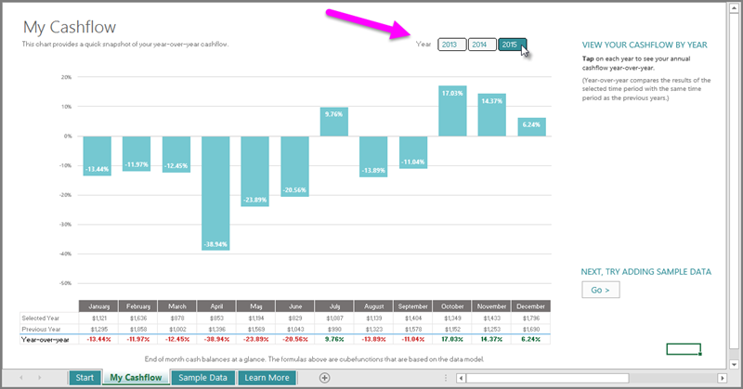

### Enter your own cash flow data

It's interesting to see the sample data that was included with the template, but it's much more interesting with your own data. To enter your own numbers - whether real numbers, or just experimenting with the template to get a feel for how it works - select the **Sample Data** worksheet tab. Notice the **TRY IT** instructions, to the right of the table, that provide guidance and a button to enter your own sample data.

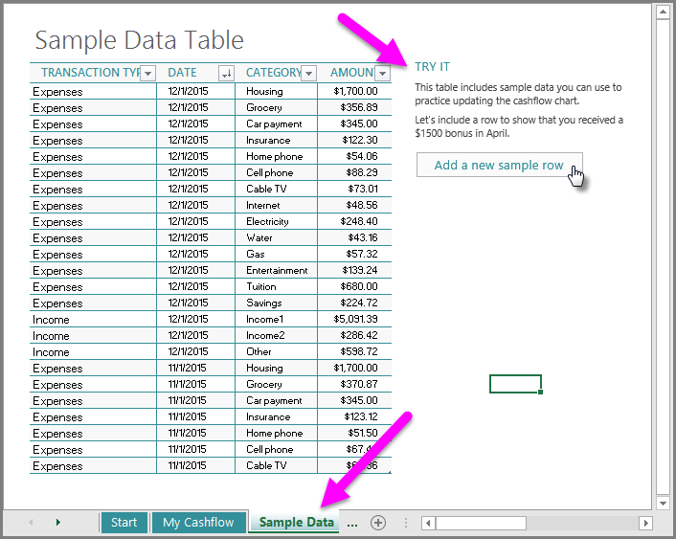

Once you select **Add a new sample row**, the template highlights a new row at the bottom of the table, and fills in the four columns with the following information:

* **Transaction Type** - this first column is either Income or Expense. By using only those two categories, the graph on the My Cashflow worksheet can consistently compare income to expenses. In this example the bonus is Income.
* **Date** - this is the date of the transaction. The template automatically inserts 4/1/2015, but you can apply whichever data you choose. The graph in the My Cashflow sheet groups income and expenses by month and year, based on the value in this column.
* **Category** - this column lets you categorize your income and expenses. There are quite a few categories already included, which you can choose from. You can also create a new category, especially if you expect to get lots of bonus checks, which is always nice. You can view income and expenses by category too, so entering information into this category consistently will help ensure any subsequent analysis goes smoothly.
* **Amount** - this is the amount of the income or expense. You enter positive numbers into this column (rather than using negative numbers for expenses, for example), because the calculations associated with the data model knows how to properly handle income and expenses, based on positive numbers in this column.

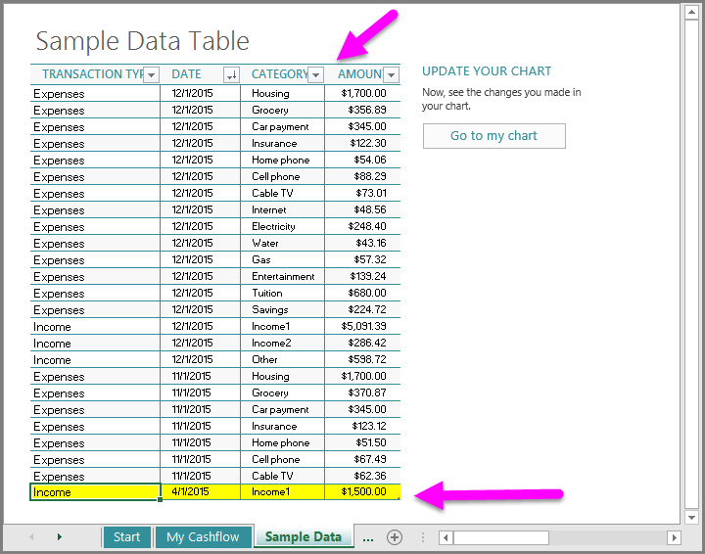

Once the data is entered, and we go back to the chart and select the Update now button (which refreshes the data model), we can see the changes reflected in the cashflow chart. With the additional $1500 income we added in the**TRY IT** instructions, the month of April went from being down 38.94% compared to the previous year, to being up 68.48% over the previous year.

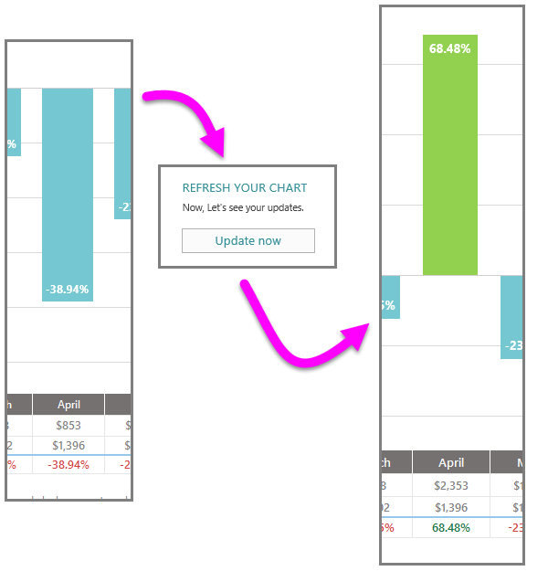

### Using the Excel Data Model

By completing the previous steps to enter additional sample data into the My Cashflow workbook, you've just interacted with the Excel data model. A *data model* is an organized collection of data elements that relate to one another in a structured, or standardized, way. In the My Cashflow data model, there are many data elements (the cashflow entries) that relate to one another by the four structured, or standardized, categories (Transaction Type, Data, Category, Amount).

Data models can be simple like this My Cashflow data model, or complex like a database or a collection of databases that are organized to relate to one another in specific ways. Data models do not have to be permanent or created solely by database engineers; data models can be created on-the-fly in Excel from various sources, to suit your own data analysis needs.

You can also analyze a data model by looking at portions of that data in particular ways, such as through graphs or other visualizations. For example, you might want to analyze only expenses for your cashflow, and only for the 2015 calendar year. By doing so, you're looking at (analyzing) a subset of the data model that meets your criteria, and gaining insights from what you see. Just like data models, visualizations and data analysis can be simple (such as: a graph of how much I spent on my Internet bill in 2015) or complex.

### Enable Data Analysis add-ins

Excel 2016 includes a powerful data modeling feature called **Power Pivot**. To enable Power Pivot and other data analysis add-ins, select **File > Options** to bring up the **Excel Options** window. Select **Advanced** from the left pane, then scroll down to the **Data** section, which is near the bottom of the scrolled window. At the bottom of the Data section, there's an option to **Enable Data Analysis add-ins: Power Pivot, Power View, and Power Map**.

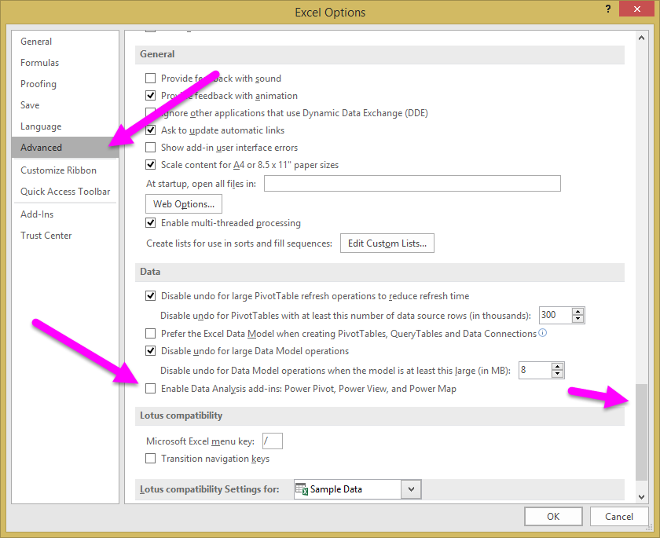

Select the checkbox, and then select **OK**.

When the data analysis add-ins are enabled, the **Manage Data Model** button appears in the **Data Tools** section of the **Data** ribbon. When we select the **Manage Data Model** button, the Power Pivot data modeling window appears.

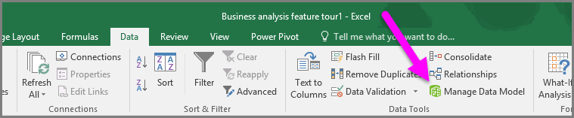

### Using Time Intelligence in Excel 2016 with Measures

The My Cashflow template uses a few of the time intelligence capabilities of Excel 2016, such as the year-over-year comparison demonstrated earlier in this article. These time intelligence capabilities were implemented as*Measures* that were created in the data model in the template. To see these Measures, select the **Manage Data Model** button in the **Data** tab to show the **Power Pivot** window. The first measure is called *Total Cashflow*.

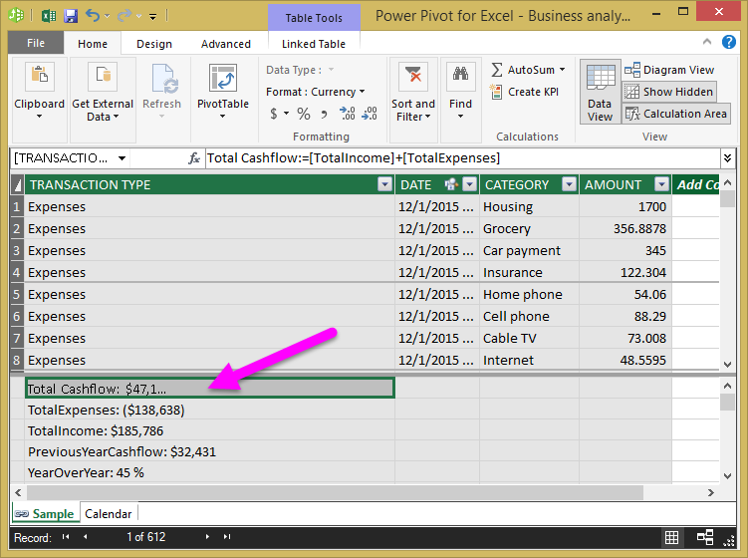

In the My Cashflow template, the year-over-year calculation compares the current year cashflow (we'll call it CYC for now) to the previous year cashflow (PYC). The formula to create the year-over-year calculation is the following:

Year-Over-Year = (CYC-PYC)/PYC

The following time intelligence Measures were included in the My Cashflow template:

* TotalIncome:=CALCULATE(sum([AMOUNT]),'Sample'[TRANSACTION TYPE]="Income")

TotalIncome summarizes the **Amount** column, but only includes values with the **Transaction Type** value specified as **Income**.

* TotalExpenses:=CALCULATE(sum([AMOUNT])\*-1,'Sample'[TRANSACTION TYPE]="Expenses")

TotalExpenses is similar to TotalIncome, where **Transaction Type** is specified as **Expense**. The result is then multiplied by -1 to reflect that the results are expenses.

* Total Cashflow:=[TotalIncome]+[TotalExpenses]

Total Cashflow is created by adding the [TotalIncome]+[TotalExpenses] measures. Creating it this way, by using measures as the building block elements in the calculation, enables future change in either of those measures to automatically be reflected in Total Cashflow.

Having Total Cashflow also enabled us to create a pivot table with our cashflow data. Adding a **Year**slicer enabled us to see a specific year's cashflow (the current year, for example). In order to create the year-over-year comparison, we also needed the previous year's cashflow, and furthermore, needed that previous year's cashflow to be presented when the slicer is showing the current year. To resolve that challenge, we created the Measure called PreviousYearCashflow.

* PreviousYearCashflow:=CALCULATE([Total Cashflow],SAMEPERIODLASTYEAR('Calendar'[Date]))

*Calculate* is a powerful function; the *Calculate*function can replace an existing filter with a new one, in order to answer analytical problems and to support users needs.

In the PreviousYearCashflow Measure we summarize the Total Cashflow we created before, and have the time dimension new context in order to get the data we wanted. Specifically: if Total Cashflow is sliced on 2015, PreviousYearCashflow presents data for 2014 by using theSAMEPERIODLASTYEAR functionality.

The formula syntax used in Measures is part of powerful analytical language called *DAX (Data Analysis Expressions)*. You can find more information about DAX in the related topics section that follows.

## Learn how to use the Stock Analysis template with Excel 2016

With Excel 2016, you can use the **Stock Analysis** template to quickly analyze and compare the performance of selected stocks over time. The template lets you select up to three stocks to compare, then displays their performance over a period of time in an Excel chart. With the **Stock Analysis** template you control the stocks to compare, and the time period for comparison.

### Using the Stock Analysis Template

To use the **Stock Analysis** template, you need Excel 2016 or later or a subscription to Office 365.

### Open the Stock Analysis template

To open the **Stock Analysis** template, in Excel select **New > Stock Analysis**.

If you can't see the template, use the search box and type *stock analysis*, and then select the magnifying glass button to begin the search (or click the **Enter** key). The **Stock Analysis** template appears.

Once the template is open, you see the first workbook tab, titled **Start**. Select the **Let’s Get Started** button to begin.

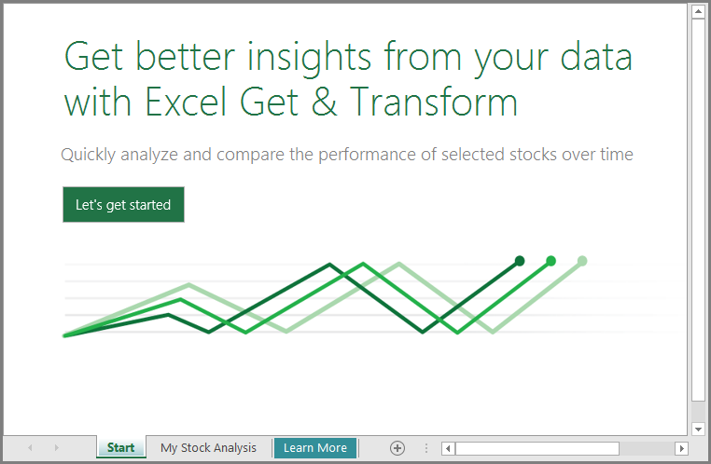

### Using the Stock Analysis Template

The **Stock Analysis** worksheet is presented, showing two stocks in the chart, which are provided in the template to get you started. These are two renewable energy companies – Canadian Solar Inc (CSIQ) and SolarCity Corp (SCTY). In the next few steps, you learn how to change the stocks that are displayed.

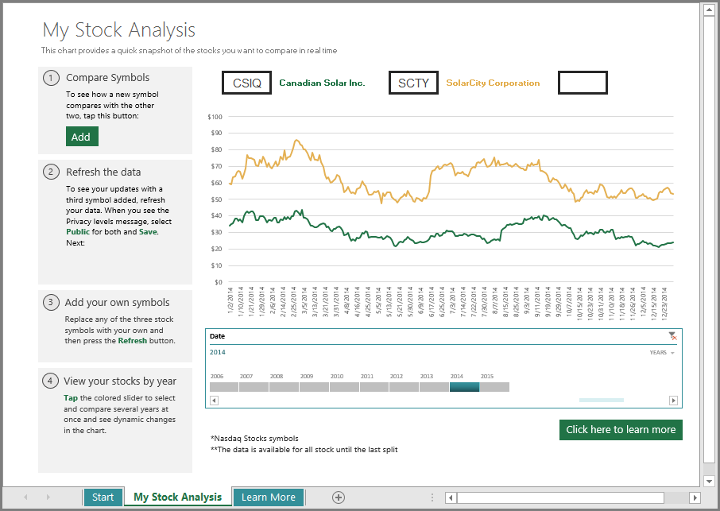

Select **Add** to add a new stock to compare. When you do so, the third box is populated with a Renewable Energy Group (REGI) symbol.

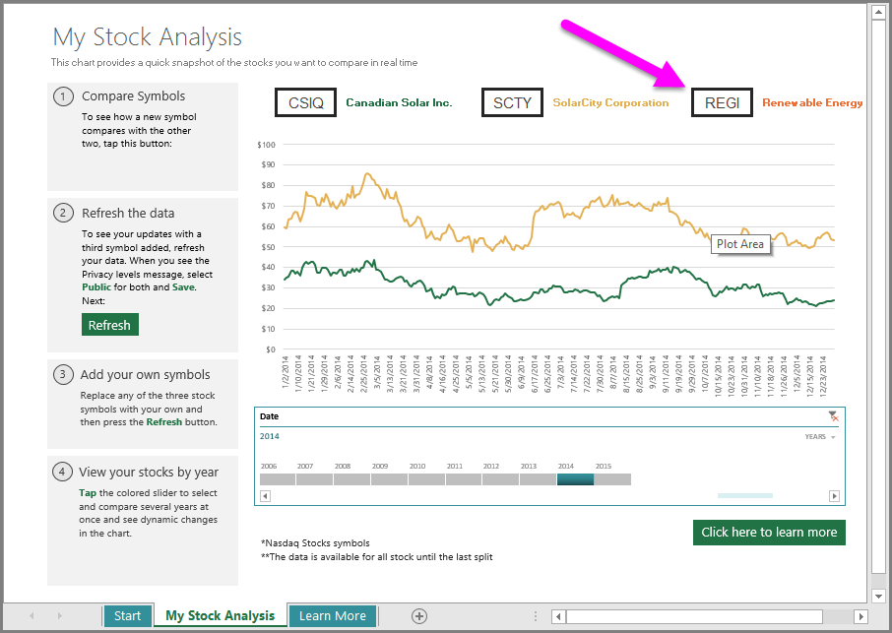

Select the **Refresh** button in the second box on the left. You're prompted with the **Privacy Levels** security dialog. In this template, you’re combining data from the local workbook with stock data downloaded from the Web, which is why the **Privacy Levels** security dialog notification appears. Choose **Public** from the drop-down box for both data sources, then select **Save**.

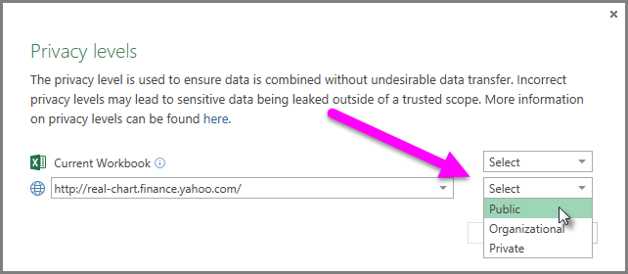

The template loads the latest stock information from the *Yahoo Finance* portal. A chart line is added to the Excel chart, displaying historical data for the REGI stock symbol.

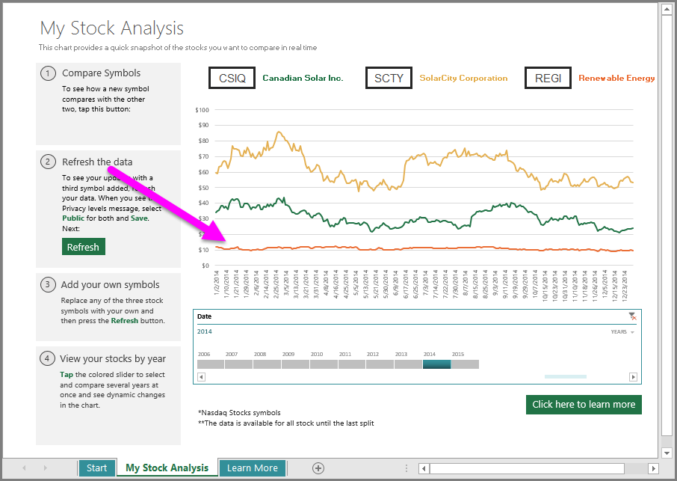

You can adjust the comparison period using the **Date**timeline slicer, found at the bottom of the worksheet. You can add more years to the comparison, narrow the analysis to the specific quarters, month or even days, all using this slicer’s drop-down selection, as shown in the following image.

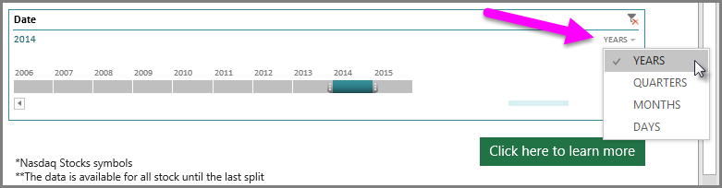

### Customizing the Stock Analysis Template with your own Stocks

Now that you know how to use the **Stock Analysis** template, replacing any of the three default stock symbols is easy. Simply enter a valid stock symbol into each of the three stock symbol boxes, then select the **Refresh** button from the left side of the workbook. The template connect to the Web, downloads the data, and refreshes the chart based on your selections.

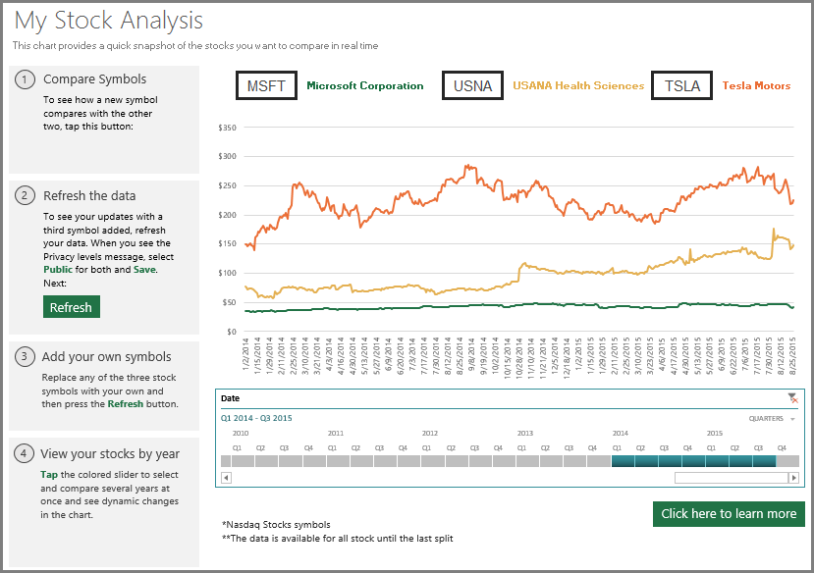

### Resetting the Stock Analysis Template

Want to get the template back to how it was when you first opened it? No problem, just press **Ctrl + Q** to reset your workbook to its initial state.

### Learn More

To learn more about the tools and the technologies used in this template, explore the links in the template’s Learn More worksheet.

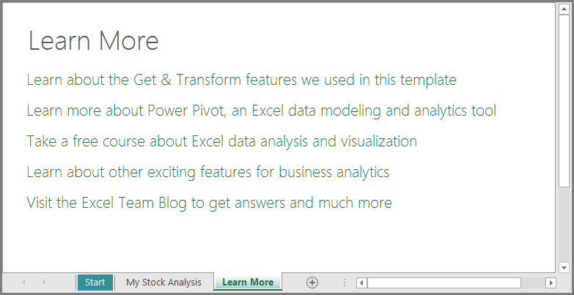

## PivotTable enhancements

Excel is known for its flexible and powerful analysis experiences, through the familiar PivotTable authoring environment. With Excel 2010 and Excel 2013, this experience was significantly enhanced with the introduction of Power Pivot and the Data Model, bringing the ability to easily build sophisticated models across your data, augment them with measures and KPIs, and then calculate over millions of rows with high speed. Here are some of the enhancements we made in Excel 2016, so that you can focus less on managing your data and more on uncovering the insights that matter.

* **Automatic relationship detection**    discovers and creates relationships among the tables used for your workbook’s data model, so you don’t have to. Excel 2016 knows when your analysis requires two or more tables to be linked together and notifies you. With one click, it does the work to build the relationships, so you can take advantage of them immediately.
* **Creating, editing and deleting custom measures**    can now be done directly from the PivotTable fields list, saving you a lot of time when you need to add additional calculations for your analysis.
* **Automatic time grouping**    helps you to use your time-related fields (year, quarter, month) in your PivotTable more powerfully, by auto-detecting and grouping them on your behalf. Once grouped together, simply drag the group to your PivotTable in one action and immediately begin your analysis across the different levels of time with drill-down capabilities.

**PivotChart drill-down buttons**    allow you to zoom in and out across groupings of time and other hierarchical structures within your data.

* **Search in the PivotTable**    field list helps you get to the fields that are important to you across your entire data set.
* **Smart rename**    gives you the ability to rename tables and columns in your workbook’s data model. With each change, Excel 2016 automatically updates any related tables and calculations across your workbook, including all worksheets and DAX formulas.
* **Multiple usability improvements**    have also been made. For example, delayed updating allows you to perform multiple changes in Power Pivot without the need to wait until each is propagated across the workbook. The changes will be propagated at one time, once the Power Pivot window is closed.

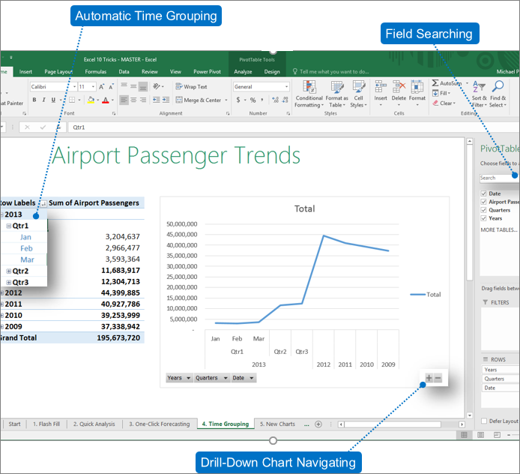

## Multi-select slicer

Now you can select multiple items in an Excel slicer on a touch device. This is a change from prior versions of Excel where only one item in a slicer could be selected at a time using touch input. You can enter Slicer multi-select mode by using the new button located in the Slicer’s label.

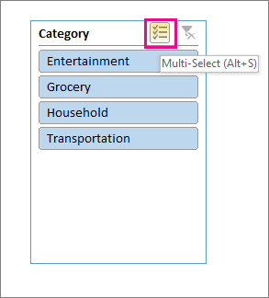

## Publish and share your analysis with Power BI

A report is not complete without being able to share it with the right people. Once you’re finished preparing your data analysis, you can share it with your workgroup or clients through Power BI with just one button. Once published to Power BI, use your data models to quickly construct interactive reports and dashboards. With Excel Online support built into Power BI service, you can also display your fully formatted Excel worksheets as well.

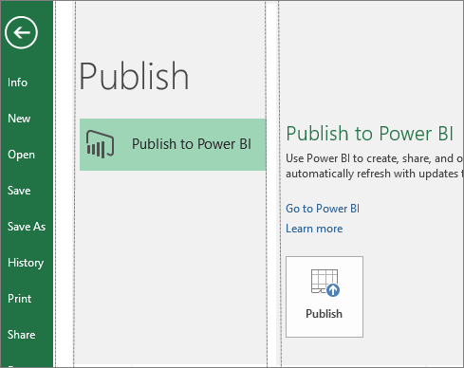

## Quick Shape Formatting

This feature increases the number of default shape styles by introducing new “preset” styles in Excel.

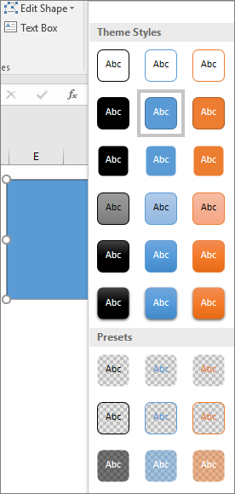

## Insert pictures with the correct orientation

With automatic image rotation, once you insert an image into Excel, it automatically rotates the picture to match the camera’s orientation. You can manually rotate the image to any position after insertion. Note that this only affects newly inserted images and does not apply to pictures in existing documents.

## Do things quickly with Tell Me

You'll notice a text box on the ribbon in Excel 2016 that says **Tell me what you want to do**. This is a text field where you can enter words and phrases related to what you want to do next and quickly get to features you want to use or actions you want to perform. You can also choose to get help related to what you're looking for, or perform a Smart Lookup on the term you entered.

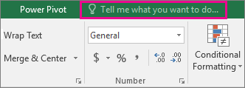

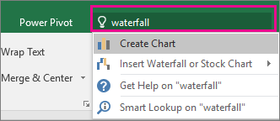

## Insights into what you're working on

The Insights pane, powered by Bing, offers more than just definitions. When you select a word or phrase, right-click it, and choose **Smart Lookup**, the insights pane will open with definitions, Wiki articles, and top related searches from the web. You can also get to Smart Lookup any time by going to **Review** > **Smart Lookup** and entering a query there.

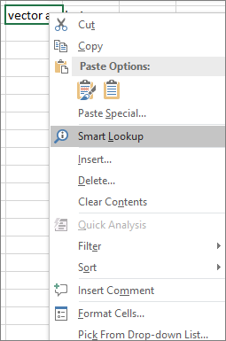 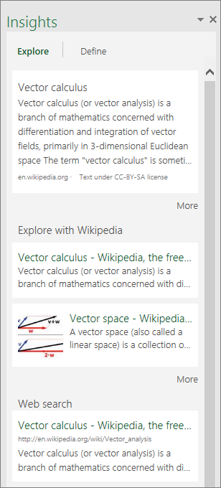

## Ink Equations

Including math equations has gotten much easier. Now, you can go to **Insert** > **Equation** > **Ink Equation**, any time you want to include a complex math equation in your workbook. If you have a touch device, you can use your finger or a touch stylus to write math equations by hand, and Excel will convert it to text. (If you don't have a touch device, you can use a mouse to write, too). You can also erase and select and correct what you've written as you go.

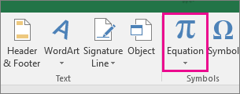

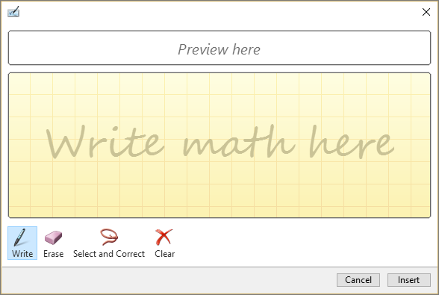

## Simpler sharing

Choose **Share** on the ribbon to share your spreadsheet with others on SharePoint, OneDrive, or OneDrive for Business.

These changes bring together two key aspects of collaboration: who has access to a given document and who is currently working with you on the document. Now you can view both pieces of information in one place from the Share dialog box.

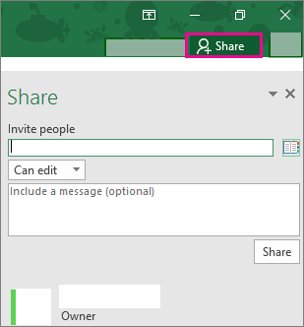

## Improved version history

Now you can go to **File** > **History** to see a complete list of changes that have been made to your workbook and access earlier versions.

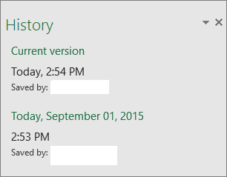

**NOTE:** This feature is only supported for files stored on OneDrive for Business or SharePoint.

## New themes

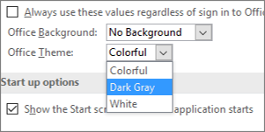

There are now three Office themes that you can apply : Colorful, Dark Gray, and White. To access these themes, go to **File** > **Options** > **General**, and then click the drop down menu next to **Office Theme**.

## Data Loss Protection (DLP) in Excel

Data Loss Protection (DLP) is a high-value enterprise feature that is well loved in Outlook. We are introducing DLP in Excel to enable real time scan of content based on a set of predefined policies for the most common sensitive data types (e.g., credit card number, social security number, and US bank account number). This capability will also enable the synchronization of DLP policies from Office 365 in Excel, Word, and PowerPoint, and provide organizations with unified policies across content stored in Exchange, SharePoint and OneDrive for Business.

icture of Policy Tip message

## Power Pivot - Overview and Learning

**Power Pivot** is a data modeling technology that lets you create data models, establish relationships, and create calculations. With Power Pivot you can work with large data sets, build extensive relationships, and create complex (or simple) calculations, all in a high-performance environment, and all within the familiar experience of Excel.

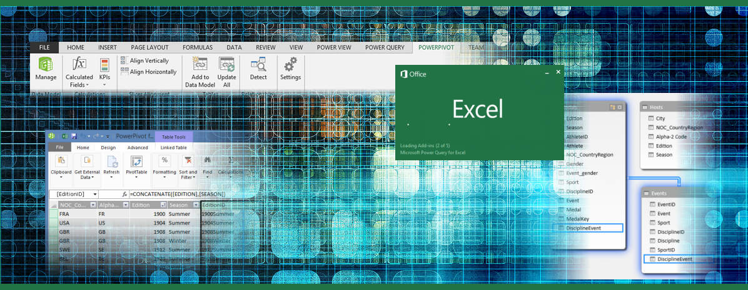

Power Pivot is one of three data analysis tools available in Excel:

* Power Pivot
* [Power Query](https://support.office.com/en-us/article/Power-Query-ed614c81-4b00-4291-bd3a-55d80767f81d)
* [Power View](https://support.office.com/en-us/article/Power-View-5380e429-3ee0-4be2-97b7-64d7930020b6)

Power Pivot Resources

The following links and information can get you going with Power Pivot, including how to enable Power Query in Excel, how to get started using Power Pivot, then tutorials, and community connections.

How do I get Power Pivot?

Power Pivot is available as an add-in for Excel, which you can [enable by following a few simple steps](https://support.office.com/en-us/article/enable-by-following-a-few-simple-steps-a891a66d-36e3-43fc-81e8-fc4798f39ea8). The underlying modeling technology found in Power Pivot is also found in the [Power BI Designer](https://support.powerbi.com/knowledgebase/articles/471664), which is part of the[Power BI](https://powerbi.com/) service offered from Microsoft.

Getting Started with Power Pivot

When the **Power Pivot add-on** is enabled, the **Power Pivot** tab in the ribbon is available, as shown in the following image.

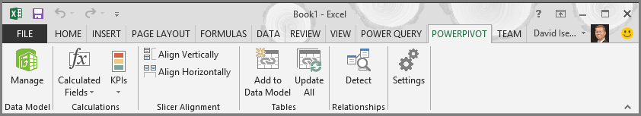

From the **Power Pivot** ribbon tab, select **Manage** from the **Data Model** section, as shown below.

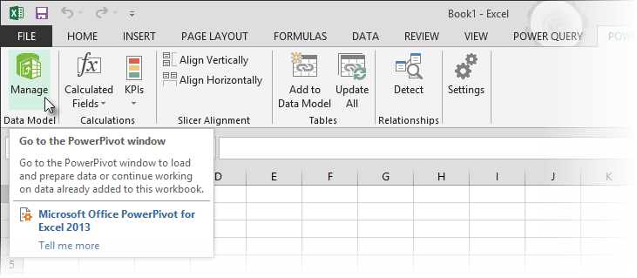

When you select **Manage**, the **Power Pivot window** appears, which is where you can view and manage the data model, add calculations, establish relationships, and see elements of your Power Pivot *data model*. A **data model**is a collection of tables or other data, often with established relationships among them. The following image shows the **Power Pivot window**.

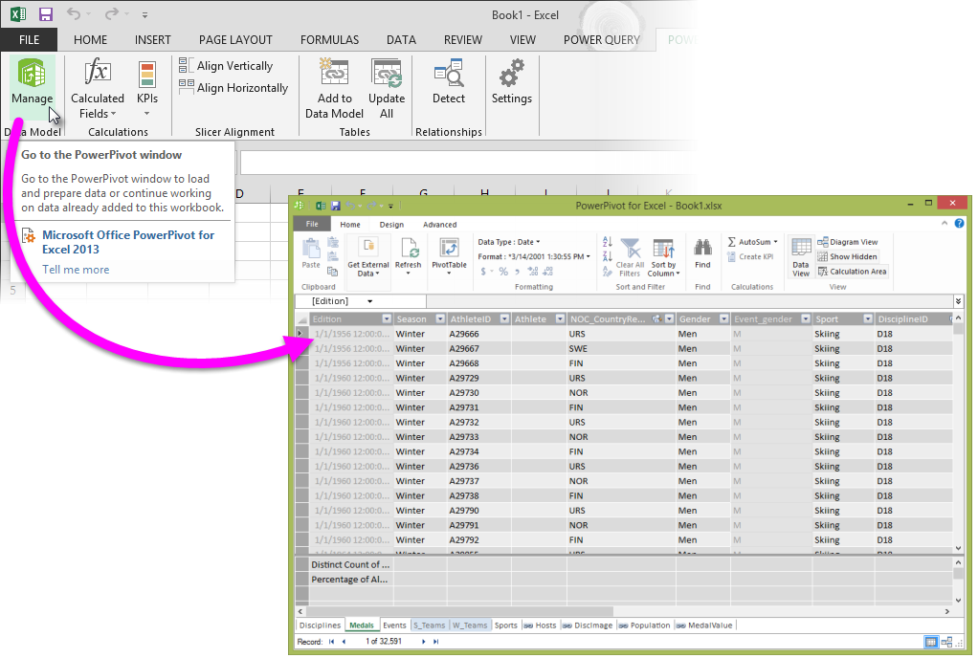

The **Power Pivot window** can also establish, and graphically represent, relationships between the data included in the model. By selecting the **Diagram view** icon from the bottom right side of the **Power Pivot window**, you can see the existing relationships in the Power Pivot data model. The following image shows the **Power Pivot window**in **Diagram view**.

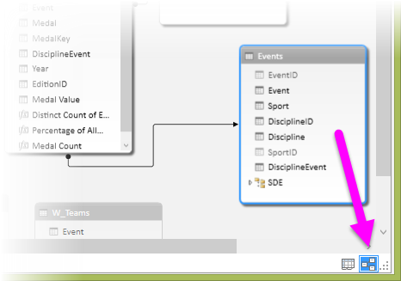

For a short tutorial about how to use Power Pivot, take a look at the following resource:

* [Tutorial: Extend Data Model relationships using Excel, Power Pivot, and DAX](https://support.office.com/en-us/article/Tutorial-Extend-Data-Model-relationships-using-Excel-Power-Pivot-and-DAX-cf7197d3-1938-490e-93fb-20371e8dd67a)

In addition to that tutorial, the following link provides an *extensive* set of links, resources, and additional information on Power Pivot:

* [Power Pivot Help](https://support.office.com/en-us/article/Power-Pivot-Help-241aac41-92e3-4e46-ae58-2f2cd7dbcf4f)

In the following sections, you’ll find additional resources and tutorials that go into detail about how to use Power Pivot, and how it can be combined with Power Query and Power View to perform powerful, intuitive self-service business intelligence tasks in Excel.

Power Pivot Tutorials

Seeing Power Pivot in action can help you learn how to use it, and provide helpful use cases that demonstrate the power of Power Pivot. The following tutorials can help you get started:

* [Create a Data Model in Excel](https://support.office.com/en-us/article/Create-a-Data-Model-in-Excel-87e7a54c-87dc-488e-9410-5c75dbcb0f7b) (starts with a basic data model, refines with Power Pivot)
* [Import Data into Excel, and Create a Data Model](https://support.office.com/en-us/article/Import-Data-into-Excel-and-Create-a-Data-Model-4b4e5ab4-60ee-465e-8195-09ebba060bf0) (first in a **six-part end-to-end** tutorial series)
* [Optimize your Data Model for Power View reporting](https://support.office.com/en-us/article/Optimize-your-Data-Model-for-Power-View-reporting-f967bdca-ef91-4c05-b4b9-cf06917ba16e)
* [QuickStart: Learn DAX Basics in 30 Minutes](https://support.office.com/en-us/article/QuickStart-Learn-DAX-Basics-in-30-Minutes-51744643-c2a5-436a-bdf6-c895762bec1a)

Additional information on Power Pivot

Power Pivot can be simple to use and fast to execute. It also can create powerful and complex calculations, indicators, and formulas. Take a look at the following links to get oriented to the many things you can do with Power Pivot.

* [Create a memory-efficient Data Model using Excel 2013 and the Power Pivot add-in](https://support.office.com/en-us/article/Create-a-memoryefficient-Data-Model-using-Excel-2013-and-the-Power-Pivot-addin-951c73a9-21c4-46ab-9f5e-14a2833b6a70)
* [Understanding Calculations in Power Pivot](https://support.office.com/en-us/article/Understanding-Calculations-in-Power-Pivot-7e4475e2-85c2-4496-9045-431412137b37)
* [Data Analysis Expressions (DAX) in Power Pivot](https://support.office.com/en-us/article/Data-Analysis-Expressions-DAX-in-Power-Pivot-bab3fbe3-2385-485a-980b-5f64d3b0f730)
* [Hierarchies in Power Pivot](https://support.office.com/en-us/article/Hierarchies-in-Power-Pivot-002cf883-3b5f-497c-bfa1-ab2271cdb73b)
* [Aggregations in Power Pivot](https://support.office.com/en-us/article/Aggregations-in-Power-Pivot-f36a448a-4962-4baf-baa2-68187b6387ce)
* [Power Pivot: Powerful data analysis and data modeling in Excel](https://support.office.com/en-us/article/Power-Pivot-Powerful-data-analysis-and-data-modeling-in-Excel-d7b119ed-1b3b-4f23-b634-445ab141b59b) (data model comparison)
* [Workbook Size Optimizer](http://www.microsoft.com/en-us/download/details.aspx?id=38793) (download)

For an extensive set of links and helpful information, take a look (again) at the following link:

* [Power Pivot Help](https://support.office.com/en-us/article/Power-Pivot-Help-241aac41-92e3-4e46-ae58-2f2cd7dbcf4f)

Forums and Related Links

There are all sorts of people using Power Query, and they like to share what they’ve learned. Take a look at the following resources to get involved with others in the Power Query community.

* [Power Pivot forum](https://social.msdn.microsoft.com/Forums/sqlserver/en-US/home?forum=sqlkjpowerpivotforexcel).
* [Data Analysis Expressions (DAX) in Power Pivot](https://support.office.com/en-us/article/Data-Analysis-Expressions-DAX-in-Power-Pivot-bab3fbe3-2385-485a-980b-5f64d3b0f730)

## Data Analysis Expressions (DAX) in Power Pivot

Data Analysis Expressions (DAX) sounds a little intimidating at first, but don’t let the name fool you. DAX basics are really quite easy to understand. First things first - DAX is NOT a programming language. DAX is a formula language. You can use DAX to define custom calculations for [Calculated Columns](https://support.office.com/en-us/article/Calculated-Columns-a0eb7167-33fc-4ade-a23f-fb9217c193af) and for [Measures](https://support.office.com/en-us/article/Measures-86484821-a324-4da3-803b-82fd2e5033f4) (also known as calculated fields). DAX includes some of the functions used in Excel formulas, and additional functions designed to work with relational data and perform dynamic aggregation.

Understanding DAX Formulas

DAX formulas are very similar to Excel formulas. To create one, you type an equal sign, followed by a function name or expression, and any required values or arguments. Like Excel, DAX provides a variety of functions that you can use to work with strings, perform calculations using dates and times, or create conditional values.

However, DAX formulas are different in the following important ways:

* If you want to customize calculations on a row-by-row basis, DAX includes functions that let you use the current row value or a related value to perform calculations that vary by context.
* DAX includes a type of function that returns a table as its result, rather than a single value. These functions can be used to provide input to other functions.
* [Time Intelligence Functions](https://support.office.com/en-us/article/Time-Intelligence-Functions-0571dcda-e4e8-42a8-b205-e1f0f9301b26)in DAX allow calculations using ranges of dates, and compare the results across parallel periods.

Where to Use DAX Formulas

You can create formulas in Power Pivot either in calculated columns or in calculated fields.

**Calculated Columns**

A calculated column is a column that you add to an existing Power Pivot table. Instead of pasting or importing values in the column, you create a DAX formula that defines the column values. If you include the Power Pivot table in a PivotTable (or PivotChart), the calculated column can be used as you would any other data column.

The formulas in calculated columns are much like the formulas that you create in Excel. Unlike in Excel, however, you cannot create a different formula for different rows in a table; instead, the DAX formula is automatically applied to the entire column.

When a column contains a formula, the value is computed for each row. The results are calculated for the column as soon as you create the formula. Column values are only recalculated if the underlying data is refreshed or if manual recalculation is used.

You can create calculated columns that are based on measures and other calculated columns. However, avoid using the same name for a calculated column and a measure, as this can lead to confusing results. When referring to a column, it is best to use a fully qualified column reference, to avoid accidentally invoking a measure.

For more detailed information, see [Calculated Columns in Power Pivot](https://support.office.com/en-us/article/Calculated-Columns-in-Power-Pivot-a0eb7167-33fc-4ade-a23f-fb9217c193af).

**Measures**

A measure is a formula that is created specifically for use in a PivotTable (or PivotChart) that uses Power Pivot data. Measures can be based on standard aggregation functions, such as COUNT or SUM, or you can define your own formula by using DAX. A measure is used in the **Values** area of a PivotTable. If you want to place calculated results in a different area of a PivotTable, use a calculated column instead.

When you define a formula for an explicit measure, nothing happens until you add the measure into a PivotTable. When you add the measure, the formula is evaluated for each cell in the **Values** area of the PivotTable. Because a result is created for each combination of row and column headers, the result for the measure can be different in each cell.

The definition of the measure that you create is saved with its source data table. It appears in the PivotTable Fields list and is available to all users of the workbook.

For more detailed information, see [Measures in Power Pivot](https://support.office.com/en-us/article/Measures-in-Power-Pivot-86484821-a324-4da3-803b-82fd2e5033f4).

Creating Formulas by Using the Formula Bar

Power Pivot, like Excel, provides a formula bar to make it easier to create and edit formulas, and AutoComplete functionality, to minimize typing and syntax errors.

**To enter the name of a table**   Begin typing the name of the table. Formula AutoComplete provides a dropdown list containing valid names that begin with those letters.

**To enter the name of a column**   Type a bracket, and then choose the column from the list of columns in the current table. For a column from another table, begin typing the first letters of the table name, and then choose the column from the AutoComplete dropdown list.

For more details and a walkthrough of how to build formulas, see [Create Formulas for Calculations in Power Pivot](https://support.office.com/en-us/article/Create-Formulas-for-Calculations-in-Power-Pivot-9996930f-a43c-4d61-92dd-489b77a3a6da).

Tips for Using AutoComplete

You can use Formula AutoComplete in the middle of an existing formula with nested functions. The text immediately before the insertion point is used to display values in the drop-down list, and all of the text after the insertion point remains unchanged.

Defined names that you create for constants do not display in the AutoComplete drop-down list, but you can still type them.

Power Pivot does not add the closing parenthesis of functions or automatically match parentheses. You should make sure that each function is syntactically correct or you cannot save or use the formula.

Using Multiple Functions in a Formula

You can nest functions, meaning that you use the results from one function as an argument of another function. You can nest up to 64 levels of functions in calculated columns. However, nesting can make it difficult to create or troubleshoot formulas.

Many DAX functions are designed to be used solely as nested functions. These functions return a table, which cannot be directly saved as a result; it should be provided as input to a table function. For example, the functions SUMX, AVERAGEX, and MINX all require a table as the first argument.

**NOTE:**  Some limits on nesting of functions exist within measures, to ensure that performance is not affected by the many calculations required by dependencies among columns.

Comparing DAX Functions and Excel Functions

The DAX function library is based on the Excel function library, but the libraries have many differences. This section summarizes the differences and similarities between Excel functions and DAX functions.

* Many DAX functions have the same name and the same general behavior as Excel functions but have been modified to take different types of inputs, and in some cases, might return a different data type. Generally, you cannot use DAX functions in an Excel formula or use Excel formulas in Power Pivot without some modification.
* DAX functions never take a cell reference or a range as reference, but instead DAX functions take a column or table as reference.
* DAX date and time functions return a datetime data type. In contrast, Excel date and time functions return an integer that represents a date as a serial number.
* Many of the new DAX functions either return a table of values or make calculations based on a table of values as input. In contrast, Excel has no functions that return a table, but some functions can work with arrays. The ability to easily reference complete tables and columns is a new feature in Power Pivot.
* DAX provides new lookup functions that are similar to the array and vector lookup functions in Excel. However, the DAX functions require that a relationship is established between the tables.
* The data in a column is expected to always be of the same data type. If the data is not the same type, DAX changes the entire column to the data type that best accommodates all values.

DAX Data Types

You can import data into a Power Pivot data model from many different data sources that might support different data types. When you import or load the data, and then use the data in calculations or in PivotTables, the data is converted to one of the Power Pivot data types. For a list of the data types, see [Data types in Data Models](https://support.office.com/en-us/article/Data-types-in-Data-Models-e2388f62-6122-4e2b-bcad-053e3da9ba90).

The table data type is a new data type in DAX that is used as the input or output to many new functions. For example, the FILTER function takes a table as input and outputs another table that contains only the rows that meet the filter conditions. By combining table functions with aggregation functions, you can perform complex calculations over dynamically defined data sets. For more information, see [Aggregations in Power Pivot](https://support.office.com/en-us/article/Aggregations-in-Power-Pivot-f36a448a-4962-4baf-baa2-68187b6387ce).

Formulas and the Relational Model

The Power Pivot window is an area where you can work with multiple tables of data and connect the tables in a relational model. Within this data model, tables are connected to each other by relationships, which let you create correlations with columns in other tables and create more interesting calculations. For example, you can create formulas that sum values for a related table and then save that value in a single cell. Or, to control the rows from the related table, you can apply filters to tables and columns. For more information, see [Relationships between tables in a Data Model](https://support.office.com/en-us/article/Relationships-between-tables-in-a-Data-Model-533dc2b6-9288-4363-9538-8ea6e469112b).

Because you can link tables by using relationships, your PivotTables can also include data from multiple columns that are from different tables.

However, because formulas can work with entire tables and columns, you need to design calculations differently than you do in Excel.

* In general, a DAX formula in a column is always applied to the entire set of values in the column (never to only a few rows or cells).
* Tables in Power Pivot must always have the same number of columns in each row, and all rows in a column must contain the same data type.
* When tables are connected by a relationship, you are expected to make sure that the two columns used as keys have values that match, for the most part. Because Power Pivot does not enforce referential integrity, it is possible to have non-matching values in a key column and still create a relationship. However, the presence of blank or non-matching values might affect the results of formulas and the appearance of PivotTables. For more information, see [Lookups in Power Pivot Formulas](https://support.office.com/en-us/article/Lookups-in-Power-Pivot-Formulas-1ae4c481-73e1-4976-a987-4cd30fef484b).
* When you link tables by using relationships, you enlarge the scope, or context in which your formulas are evaluated. For example, formulas in a PivotTable can be affected by any filters or column and row headings in the PivotTable. You can write formulas that manipulate context, but context can also cause your results to change in ways that you might not anticipate. For more information, see [Context in DAX Formulas](https://support.office.com/en-us/article/Context-in-DAX-Formulas-2728fae0-8309-45b6-9d32-1d600440a7ad).

Updating the Results of Formulas

Data r efresh and recalculation are two separate but related operations that you should understand when designing a data model that contains complex formulas, large amounts of data, or data that is obtained from external data sources.

Refreshing data is the process of updating the data in your workbook with new data from an external data source. You can refresh data manually at intervals that you specify. Or, if you have published the workbook to a SharePoint site, you can schedule an automatic refresh from external sources.

[Recalculation](https://support.office.com/en-us/article/Recalculation-1169df58-70f4-467f-aaa6-5eb25860598e) is the process of updating the results of formulas to reflect any changes to the formulas themselves and to reflect those changes in the underlying data. Recalculation can affect performance in the following ways:

* For a calculated column, the result of the formula should always be recalculated for the entire column, whenever you change the formula.
* For a measure, the results of a formula are not calculated until the measure is placed in the context of the PivotTable or PivotChart. The formula will also be recalculated when you change any row or column heading that affects filters on the data or when you manually refresh the PivotTable.

Troubleshooting Formulas

***Errors when writing formulas***

If you get an error when defining a formula, the formula might contain either a *syntactic error*, *semantic error*, or*calculation error*.

Syntactic errors are the easiest to resolve. They typically involve a missing parenthesis or comma. For help with the syntax of individual functions, see the DAX Function Reference.

The other type of error occurs when the syntax is correct, but the value or the column referenced does not make sense in the context of the formula. Such semantic and calculation errors might be caused by any of the following problems:

* The formula refers to a non-existing column, table, or function.
* The formula appears to be correct, but when the data engine fetches the data it finds a type mismatch, and raises an error.
* The formula passes an incorrect number or type of parameters to a function.
* The formula refers to a different column that has an error, and therefore its values are invalid.
* The formula refers to a column that has not been processed, meaning it has metadata but no actual data to use for calculations.

In the first four cases, DAX flags the entire column that contains the invalid formula. In the last case, DAX grays out the column to indicate that the column is in an unprocessed state.

**Incorrect or unusual results when ranking or ordering column values**

When ranking or ordering a column that contains value NaN (Not a Number), you might get wrong or unexpected results. For example, when a calculation divides 0 by 0, an NaN result is returned.

This is because the formula engine performs ordering and ranking by comparing the numeric values; however, NaN cannot be compared to other numbers in the column.

To assure correct results, you can use conditional statements using IF function to test for NaN values and return a numeric 0 value.

Compatibility with Analysis Services Tabular Models and DirectQuery Mode

In general, DAX formulas that you build in Power Pivot are completely compatible with Analysis Services tabular models. However, if you migrate your Power Pivot model to an Analysis Services instance, and then deploy the model in DirectQuery mode, there are some limitations.

* Some DAX formulas may return different results if you deploy the model in DirectQuery mode.
* Some formulas might cause validation errors when you deploy the model to DirectQuery mode, because the formula contains a DAX function that is not supported against a relational data source.

For more information, see Analysis Services tabular modeling documentation in SQL Server 2012 BooksOnline.